Name: ____________________________ Surname: ____________________________ N^{ber}: ____ Grade/Class: _____
Assessment: _____________________________  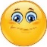 | Date: ___________________________________________________
 | Teacher’s signature:  ___________________________ | Parent’s signature:  ___________________________

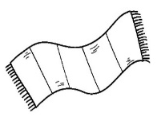
1) Listen and colour.
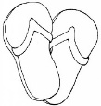
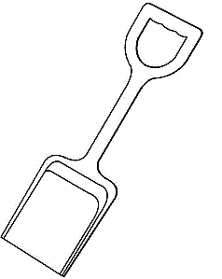

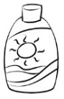
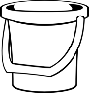

2) Circle the tick ( ) for the activities the boy likes or the cross ( ) for the activities he doesn’t like.

1st Part
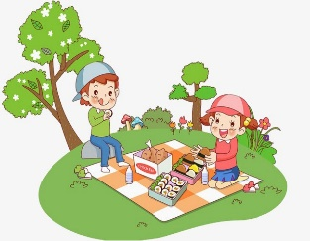
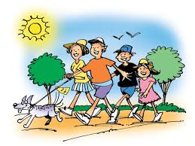
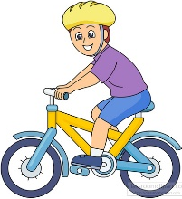
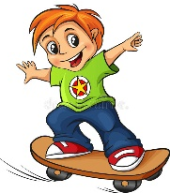
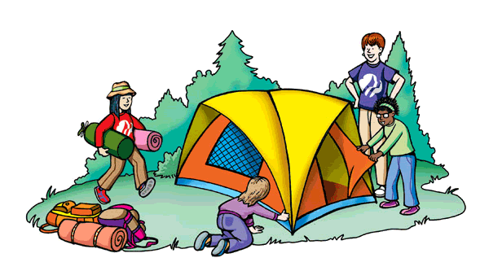

2nd Part
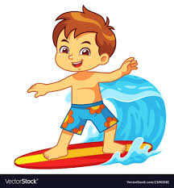
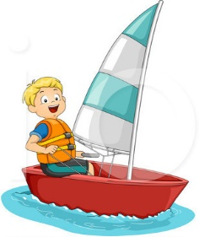
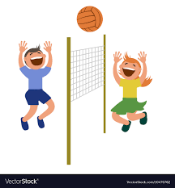
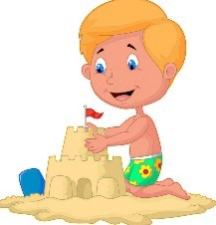
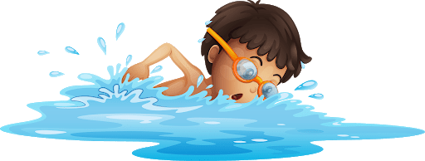

TRANSCRIPT

EXERCISE 1
- Colour the bucket red.
- The swimsuit is pink.
- The towel is blue.
- Colour the spade green.
- The flip flops are purple.
- The sunscreen is yellow.
- Colour the umbrella orange.

EXERCISE 2

1st Part
Teacher – And you Simon what are your favourite outdoor activities?
Simon – I like having a picnic or going for a walk with my family, but my favourite outdoor activity is skateboarding. I love skateboarding.
Teacher – And which one don’t you like?
Simon – I don’t like camping and I don’t like riding a bike.

2nd Part
Teacher – What about beach activities, do you like building sandcastles?
Simon – No, I hate building sandcastles and I don’t like playing volleyball.
Teacher – Which activities do you like?
Simon – I love water so, I like swimming, surfing or sailing. It’s fun!

ANSWER KEY

EXERCISE 1
- Bucket - red.
- Swimsuit - pink.
- Towel - blue.
- Spade - green.
- Flip flops - purple.
- Sunscreen - yellow.
- Umbrella - orange.

EXERCISE 2
1st part

2nd part

