Name: ____________________________ Surname: ____________________________ N^{ber}: ____ Grade/Class: _____
Assessment: _____________________________  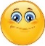 | Date: ___________________________________________________
 | Teacher’s signature:  ___________________________ | Parent’s signature:  ___________________________

1) Listen and draw lines.
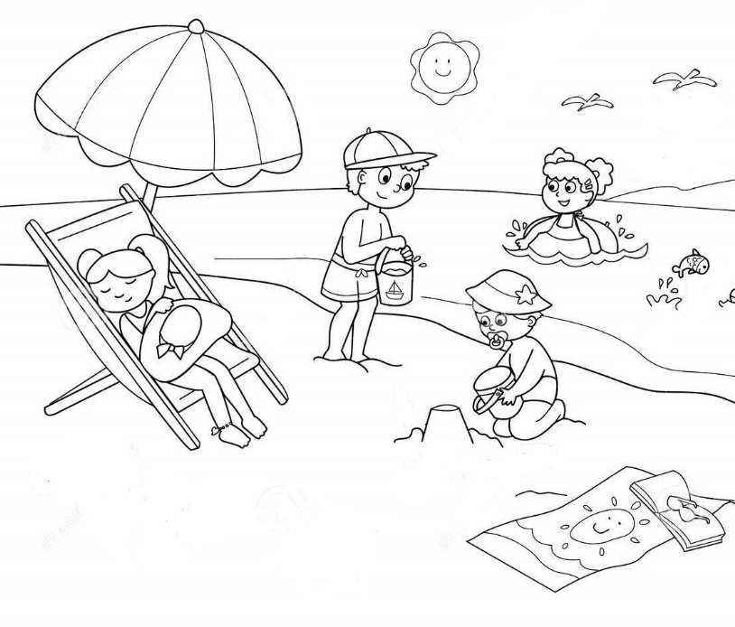
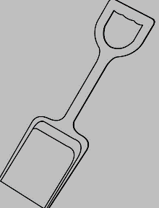

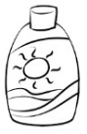
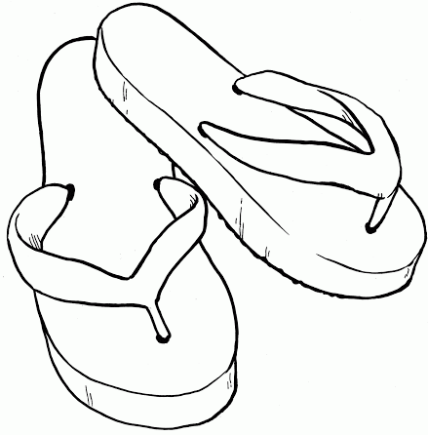

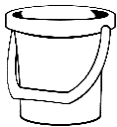
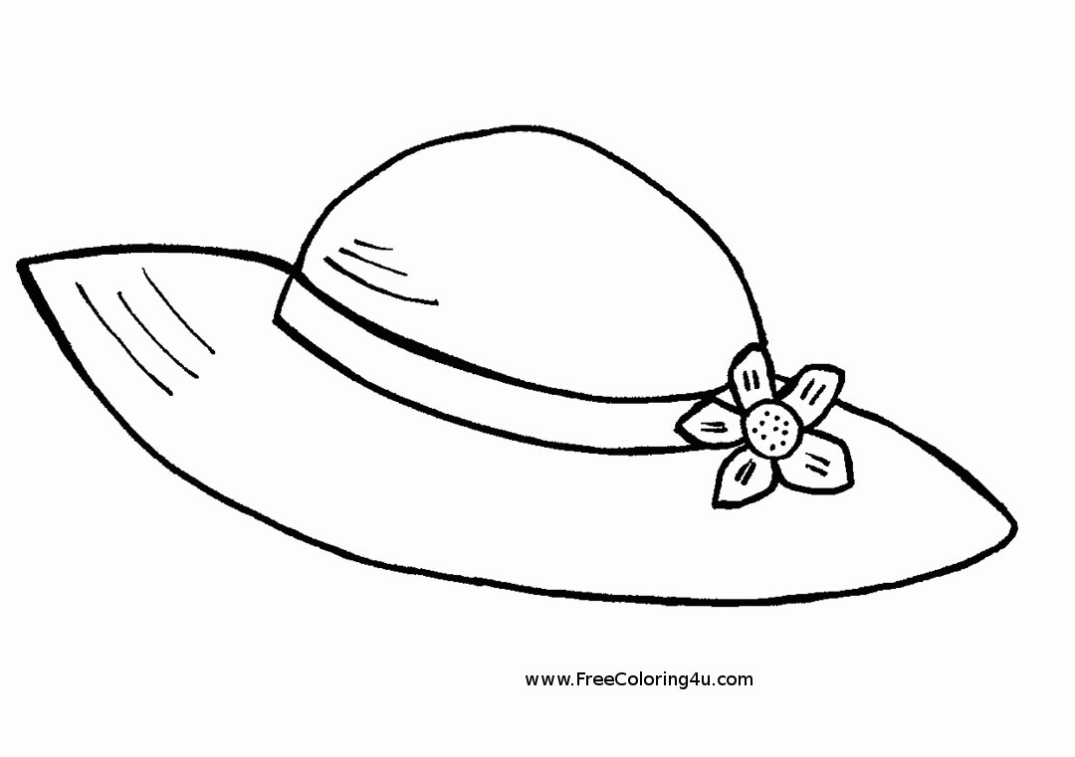

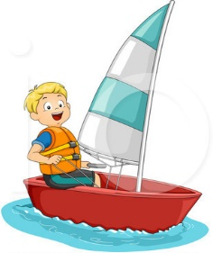
2) Listen and order the outdoor activities.
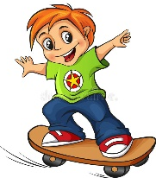
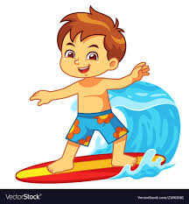
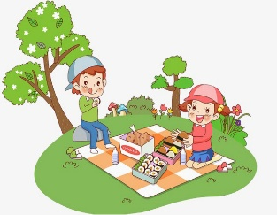

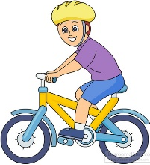
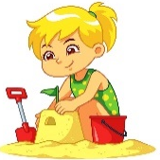
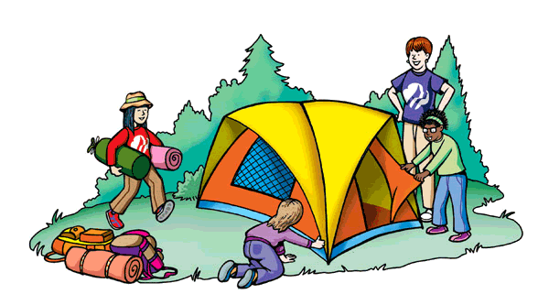
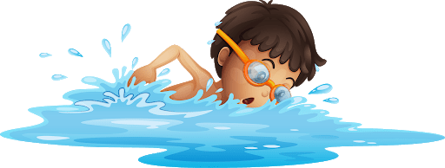

TRANSCRIPT

EXERCISE 1
One
The spade is in front of the bucket.
Two
The swimsuit is on the beach umbrella.
Three
The flip flops are near the sea.
Four
The sunscreen is under the chair.
Five
The bucket is behind the chair.
Five
The hat is on the towel.

EXERCISE 2
- Surfing
- Riding a bike
- Skateboarding
- Camping
- Building a sandcastle
- Having a picnic
- Swimming
- Sailing

ANSWER KEY

EXERCISE 1
One
The spade is in front of the bucket.
Two
The swimsuit is on the beach umbrella.
Three
The flip flops are near the sea.
Four
The sunscreen is under the chair.
Five
The bucket is behind the chair.
Five
The hat is on the towel.

EXERCISE 2

3 | 1 | 8 | 6
7 | 2 | 5 | 4

