Name: ____________________________ Surname: ____________________________ N^{ber}: ____ Grade/Class: _____
Assessment: _____________________________ | Date: ___________________________________________________
 | Teacher’s signature:  ___________________________ | Parent’s signature:  ___________________________

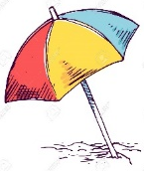
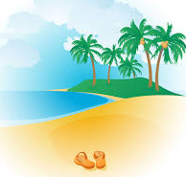
1) Listen and number.
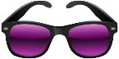

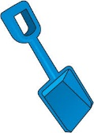
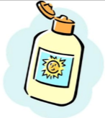
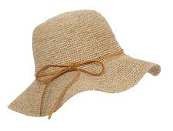

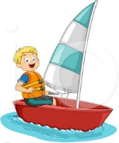
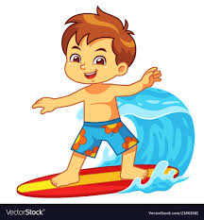
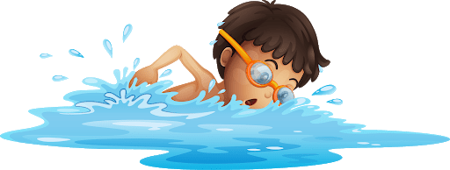
2) Listen and tick.
- Where is Jim?
a) b) c)

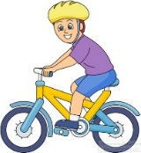
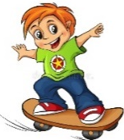
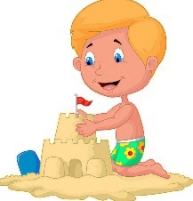

- What is Tom doing?
a) b) c)

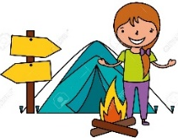
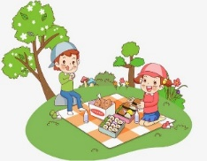

- Where are they going?
a) b) c)

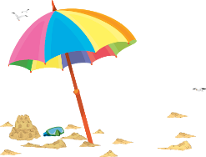
- Who is Jenny?
a) b) c)

- Who is Jack?
a) b) c)
TRANSCRIPT

EXERCISE 1

- sunglasses
- flip flops
- hat
- beach umbrella
- sea
- sand
- beach
- bucket
- swimsuit
- towel
- spade
- sunscreen

EXERCISE 2

ONE
Woman: Is that Jim swimming in the sea?
GIRL: No, Jim is sailing.
Woman: Oh, I see him.

TWO
GIRL: Where´s Tom? Is he skateboarding?
BOY: No, he’s riding a bike in the park.
GIRL: Oh yes, I can see him now. Thanks

THREE
BOY: It’s a sunny day! What about having a picnic?
GIRL: Oh no! it’s very hot!!! Let’s go to the beach, it’s better.
BOY: To the beach? Ok. Good idea!

FOUR
BOY: Where’s Jenny?
GIRL: She’s sitting on the towel.
BOY: Where? I can’t see her.
GIRL: Near the beach umbrella.

FIVE
BOY: Where is Jack?
GIRL: He’s over there near the sea.
BOY: Is he wearing shorts?
BOY: Yeah, shorts and sunglasses.

ANSWER KEY

EXERCISE 1

- sunglasses
- flip flops
- hat
- beach umbrella
- sea
- sand
- beach
- bucket
- swimsuit
- towel
- spade
- sunscreen

EXERCISE 2

- c
- a
- b
- c
- a

