Name: ____________________________ Surname: ____________________________ N^{ber}: ____ Grade/Class: _____
Assessment: _____________________________ | Date: ___________________________________________________
 | Teacher’s signature:  ___________________________ | Parent’s signature:  ___________________________
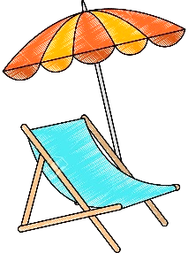
Listen and tick.

- Where’s the sunscreen?
a) b) c)
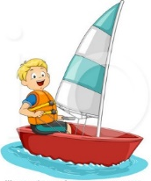
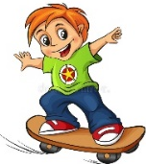
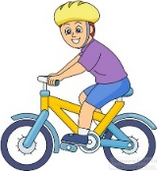

- What is Jason doing?
a) b) c)

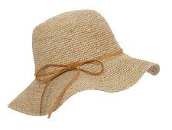
- What are the tips for sun safety?
a) b) c)

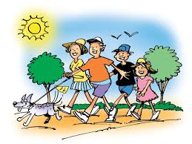
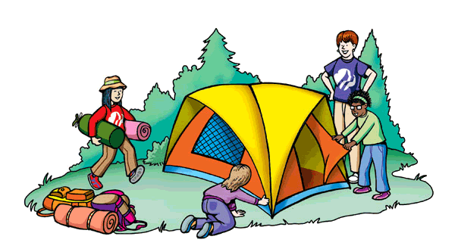
- What are they doing?
a) b) c)

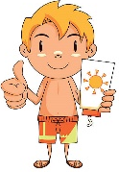
- Who’s Paul?
a) b) c)

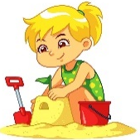
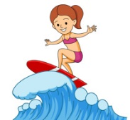
- Where is Mary?
a) b) c)

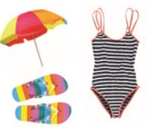
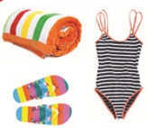
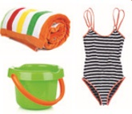
- What is Kate taking to the beach?
a) b) c)

TRANSCRIPT

EXERCISE 1

ONE
BOY: Where’s my sunscreen? I can’t see it!
GIRL: Look, It’s behind the chair.

TWO
GIRL: Where´s Jason? Is he sailing?
BOY: No, he’s skateboarding.
GIRL: Oh yes, I can see him now. Thanks

THREE
GIRL: Mum can I go to the beach?
MOTHER: Ok, but put on sunscreen and wear a hat. It’s very hot today!

FOUR
BOY: It’s a sunny day! What about going for a walk?
GIRL: Oh no! it’s too hot! Let’s have a picnic in the park instead.
BOY: A picnic? Ok. Good idea!

FIVE
BOY: Look! It’s Paul.
GIRL: Is he wearing sunglasses and a hat?
BOY: No he isn’t. He’s putting on sunscreen.
GIRL: Sorry?
BOY: Paul’s putting on sunscreen.

SIX
BOY: Is that Mary swimming in the sea?
GIRL: No, she isn’t. Mary is building a sandcastle near the sea.
BOY: Oh, I see her.

SEVEN
BOY: Hi Kate. Where are you going?
GIRL: I’m going to the beach.
BOY: Do you need a towel?
GIRL: Yes, a towel, a swimsuit and my flip flops.

ANSWER KEY

- b
- a
- b
- a
- b
- c
- c

