TOPIC: School | SUBTOPICS: summer holidays; summer activities | LEVEL: A2
Name: ____________________________ Surname: ____________________________ N^{ber}: ____ Grade/Class: _____

Read the text.

Bath, August 12
Dear grandma,
How are you? I’m great. I’m on summer holidays here in Bath and I’m having so much fun. It’s awesome! I love riding my bike and having a picnic in the park.
Ted’s got a new favourite activity, skateboarding, but he isn’t very good at it. When we go to the beach, he loves surfing and sailing. I prefer swimming and building sandcastles. Mum and dad are always on the towel under the beach umbrella. It’s very hot! We always have to wear a hat and put on sunscreen.
I miss you a lot?
Love to grandpa,
Kelly

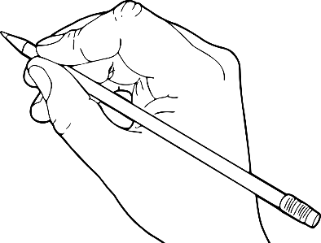

1. Write T (True) or F (False). Correct the false sentences.
a) Kelly is writing a letter to her grandfather.
b) She is on holidays with her parents and brother.
c) Her holidays are boring.
d) She doesn’t like riding her bike.
e) Ted is bad at skateboarding.
f) They always have a cap on the head.

2. Answer the questions.
- _______________________________________.
- _______________________________________.
- _______________________________________.
- _______________________________________.

a) Where is Kelly?
b) What’s the weather like there?
c) What are Ted’s favourite activities at the beach?
d) What are Kelly’s favourite activities at the beach?

3. Use words/expressions from the text to label the pictures.
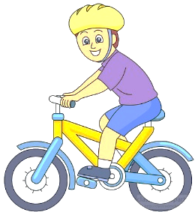
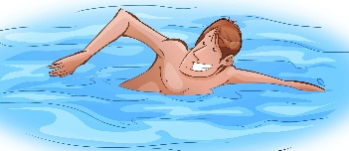

- ____________________ b) ____________________ c) ____________________
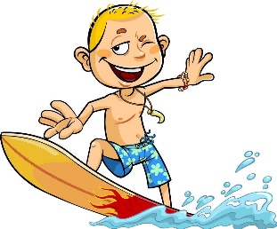
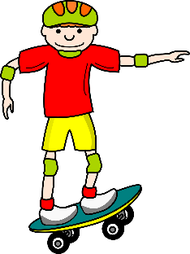

d) ____________________ e) ____________________ f) ____________________

g) ____________________

