TOPIC: Seasons | SUBTOPICS: summer holidays; summer activities | LEVEL: A2
Name: ____________________________ Surname: ____________________________ N^{ber}: ____ Grade/Class: _____

Look at the picture.
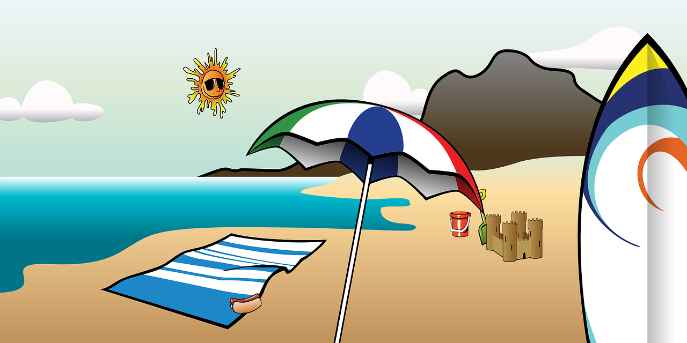

Dave

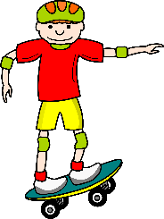

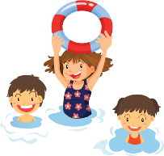
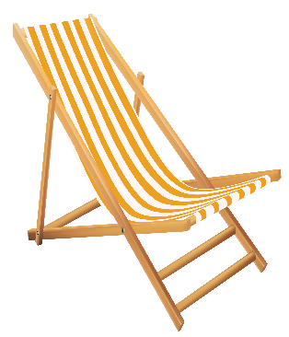

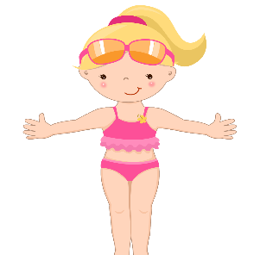

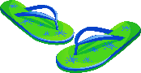
Jenny

1) Answer the questions.
_______________________.
It’s _______________ and ________________.
She is _____________ a _______________ and a _________________.
They _____ ___________ the _________________.
- What’s the season?
- What’s the weather like?
- What is the woman wearing?
- Where are the flip flops?

2) Write T (True) or F (False). Correct the false sentences.
- Three children are swimming in the sea. > _____________________________________.
- The sunglasses are behind the woman. > _____________________________________.
- There are two shovels and one bucket. > _____________________________________.
- Jenny is on the beach umbrella. > _____________________________________.
- She is putting on sunscreen. > _____________________________________.
- Dave is sailing. > _____________________________________.

