Name: ____________________________ Surname: ____________________________ N^{ber}: ____ Grade/Class: _____
Assessment: _____________________________  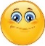  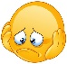  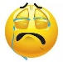 | Date: ___________________________________________________
 | Teacher’s signature:  ___________________________ | Parent’s signature:  ___________________________

- Read and complete the text.

beach umbrella * water * safety * sunglasses * beach
sunscreen * hat * cap * season * sunny

Hello, my name’s Ted and my favourite 1)________________ is summer because it’s 2)________________ and I love going to the 3)________________.
But in summer it’s time for sun 4)________________ : it’s important to wear 5)________________ to protect your eyes and have a 6)________________ or a 7)________________ on your head. Apply 8)________________ to your face, arms and legs and stay under the 9)________________ between 11 am to 4 am. Finally, drink a lot of 10)________________ .

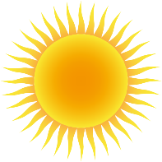
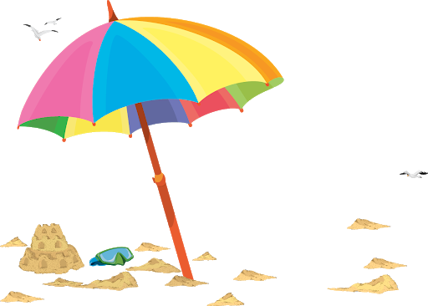
__________________

- Label the picture.

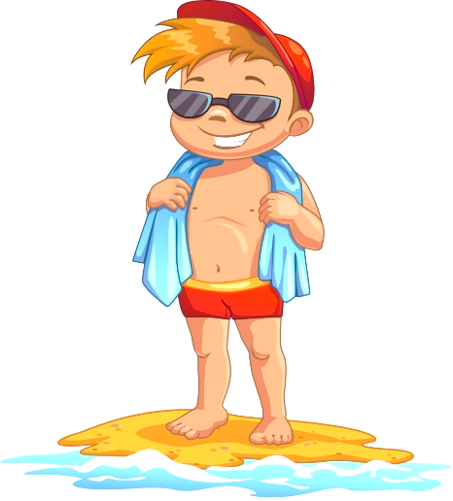
_______________
_______________
_______________

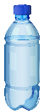

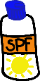
_______________

ANSWER KEY

EXERCISE 1
- season
- sunny
- beach
- safety
- sunglasses
- hat
- cap
- sunscreen
- beach umbrella
- water

EXERCISE 2
beach umbrella / cap / sunglasses / water / sunscreen

