Name: ____________________________ Surname: ____________________________ N^{ber}: ____ Grade/Class: _____
Assessment: _____________________________ | Date: ___________________________________________________
 | Teacher’s signature:  ___________________________ | Parent’s signature:  ___________________________
Look at the picture. Circle True or False.

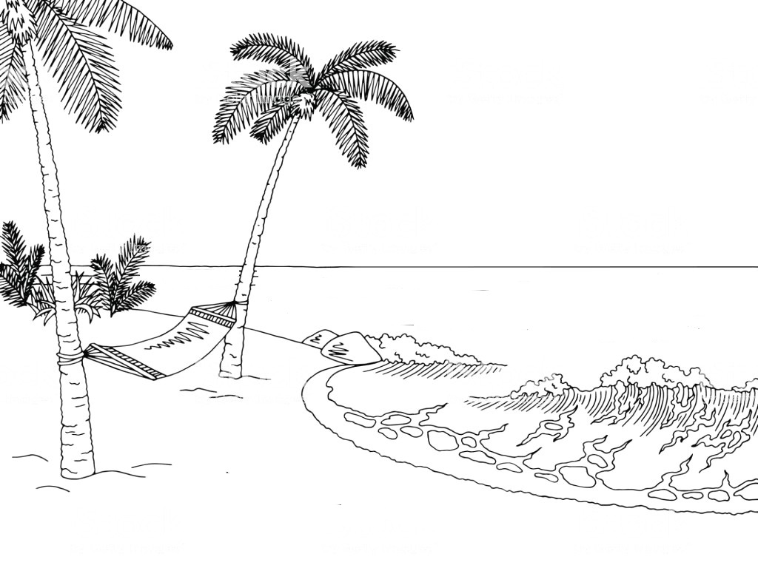

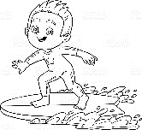
Mike
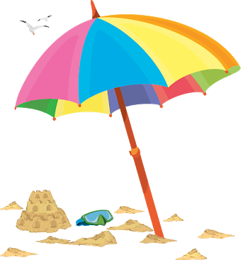
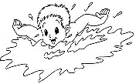

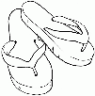
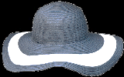
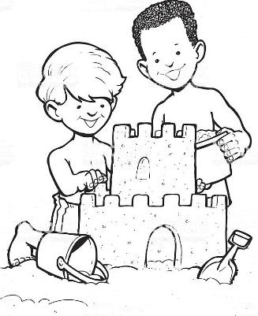
Bill
Tom
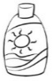

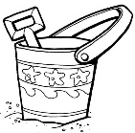
- It’s summer. True I False
- It’s sunny but it isn’t hot. True I False
- Two boys are swimming. True I False
- Mike is sailing. True I False
- Bill and Tom are building a sandcastle. True I False
- Bill’s wearing sunglasses. True I False
- There is a spade in front of the sandcastle. True I False
- There is one bucket. True I False
- The flip flops are under the beach umbrella. True I False
ANSWER KEY

- True
- False
- True
- False
- True
- False
- True
- False
- True

