Name: ____________________________ Surname: ____________________________ N^{ber}: ____ Grade/Class: _____
Assessment: _____________________________ | Date: ___________________________________________________
 | Teacher’s signature:  ___________________________ | Parent’s signature:  ___________________________

STUDENT A
- Discover if Laura is “sun smart”. Ask questions and put a ( ) or a ( ).

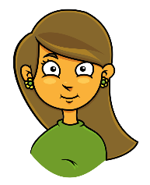  Does she…? | 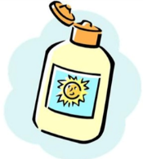 | 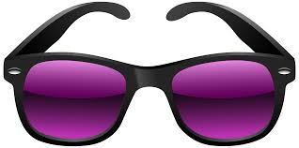 | 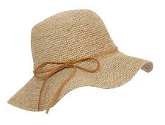 | 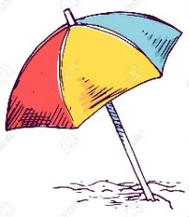 | 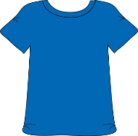
Laura

- Look and answer your partner’s questions.

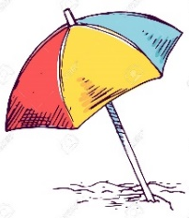
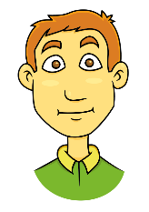

Tom

Name: ____________________________ Surname: ____________________________ N^{ber}: ____ Grade/Class: _____
Assessment: _____________________________ | Date: ___________________________________________________
 | Teacher’s signature:  ___________________________ | Parent’s signature:  ___________________________

STUDENT B

- Look and answer your partner’s questions.

Laura

- Discover if Tom is “sun smart”. Ask questions and put a ( ) or a ( ).

Does he…?

Tom

ANSWER KEY

Exercise 1
Student A: Does she put on sunscreen?
Student B: Yes, she does.
Student A: Does she wear sunglasses?
Student B: No, she doesn’t.
Student A: Does she wear a hat?
Student B: No, she doesn’t.
Student A: Does she stay under the beach umbrella?
Student B: Yes, she does.
Student A: Does she wear a T-shirt?
Student B: Yes, she does.

Exercise 2
Student B: Does he put on sunscreen?
Student A: No, he doesn’t.
Student B: Does he wear a hat?
Student A: Yes, he does.
Student B: Does he wear a T-shirt?
Student A: Yes, he does.
Student B: Does he stay under the beach umbrella?
Student A: No, he doesn’t.
Student B: Does he wear sunglasses?
Student A: Yes he does.

