Name: ____________________________ Surname: ____________________________ N^{ber}: ____ Grade/Class: _____
Assessment: _____________________________ | Date: ___________________________________________________
 | Teacher’s signature:  ___________________________ | Parent’s signature:  ___________________________

Find the 10 differences.

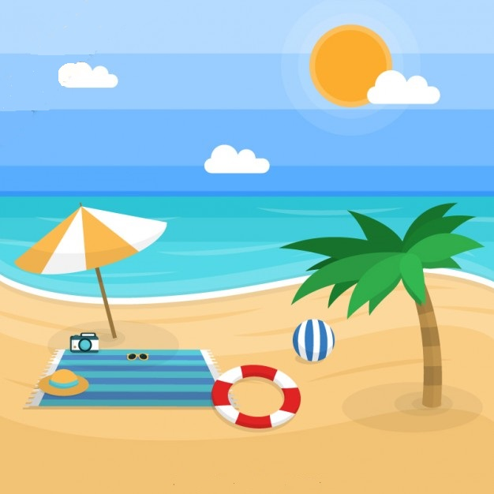
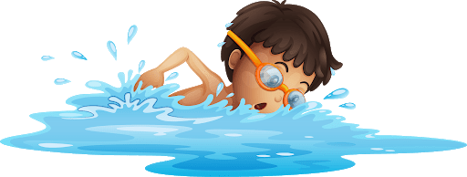
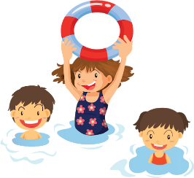
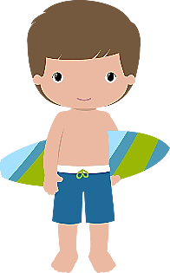

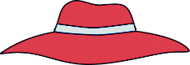

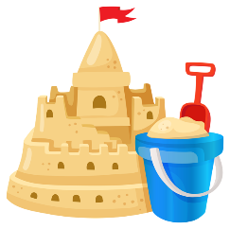

Name: ____________________________ Surname: ____________________________ N^{ber}: ____ Grade/Class: _____
Assessment: _____________________________ | Date: ___________________________________________________
 | Teacher’s signature:  ___________________________ | Parent’s signature:  ___________________________
Find the 10 differences.

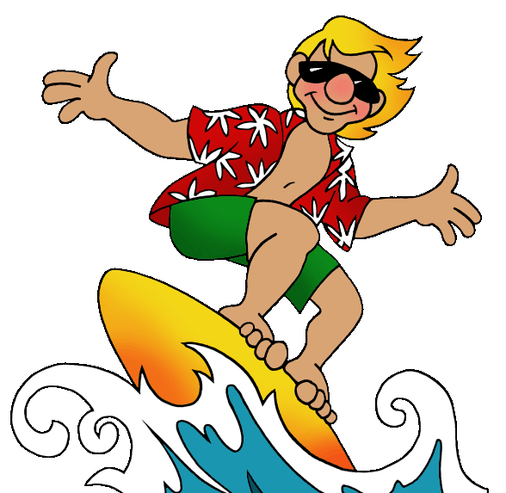

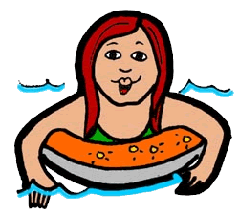

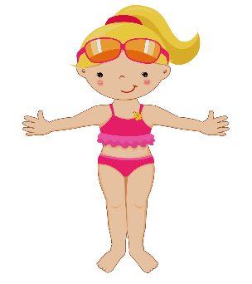
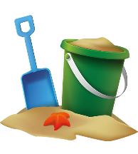

KEY ANSWER

 | PICTURE 1 | PICTURE 2
1 | A boy is swimming. | A boy is surfing.
2 | Three children are playing in the sea. | Four children are playing in the sea.
3 | In the foreground, the boy is wearing a hat. | In the foreground, the boy is wearing sunglasses.
4 | There is a sandcastle. | There is no sandcastle.
5 | The spade is in the bucket. | The spade is near the bucket.
6 | There is no seashell in front of the bucket. | There is a seashell in front of the bucket.
7 | The flip flops are on the left side. | The flip flops are on the right side.
8 | Under the palm tree, there is a boy. | Under the palm tree, there is a girl.
9 | The boy is reading. | The girl is putting on sunscreen.
10 | Under the palm tree there is a bottle of water. | Under the palm tree there is no bottle of water.

