Name: ____________________________ Surname: ____________________________ N^{ber}: ____ Grade/Class: _____
Assessment: _____________________________ | Date: ___________________________________________________
 | Teacher’s signature:  ___________________________ | Parent’s signature:  ___________________________

STUDENT A
- Discover the outdoor activities your partner likes ( ) and doesn’t like ( ).

Do you like…? | 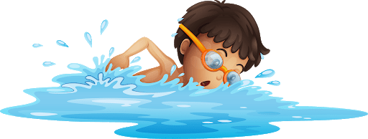 | 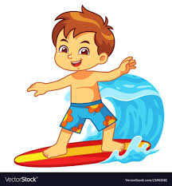 | 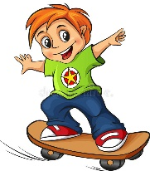 | 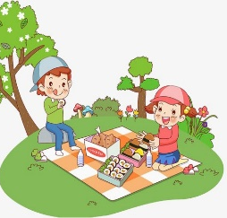 | 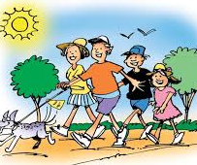
My partner

- Answer your partner´s questions.

- Tell your teacher/another student what (s)he likes.

(S)he likes… but (s)he doesn’t like…

Name: ____________________________ Surname: ____________________________ N^{ber}: ____ Grade/Class: _____
Assessment: _____________________________ | Date: ___________________________________________________
 | Teacher’s signature:  ___________________________ | Parent’s signature:  ___________________________

STUDENT B

- Answer your partner´s questions.

- Discover the outdoor activities your partner likes ( ) and doesn’t like ( ).

Do you like…? | 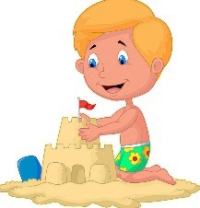 | 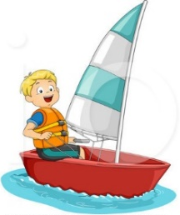 | 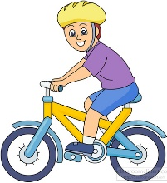 | 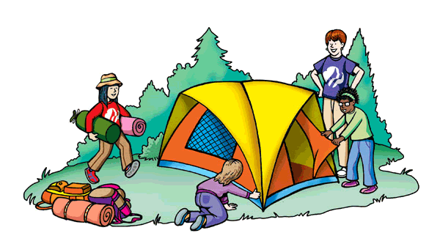 | 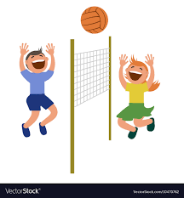
My partner

- Tell your teacher/another student what (s)he likes.

(S)he likes… but (s)he doesn’t like…

ANSWER KEY

Exercises 1 and 2
Student A:
Do you like swimming / surfing / skateboarding / having a picnic / hiking?
Student B:
Yes, I do. / No, I don’t.

Student B:
Do you like building sandcastles / sailing / riding a bike / camping / playing volleyball?
Student A:
Yes, I do. / No, I don’t.

Exercise 3
(s)he likes... / (s)he doesn’t like…

