Name: ____________________________ Surname: ____________________________ N^{ber}: ____ Grade/Class: _____
Assessment: _____________________________ | Date: ___________________________________________________
 | Teacher’s signature:  ___________________________ | Parent’s signature:  ___________________________
Group discussion
- Do you like summer holidays? Why?
- Talk about the outdoor activities you like like, don´t like, hate or love.

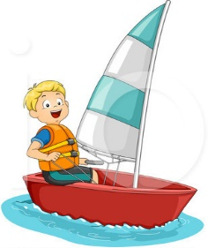
AT THE BEACH

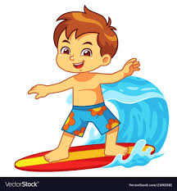
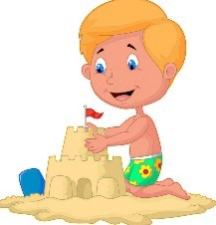
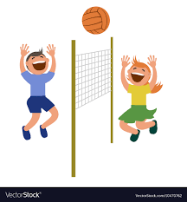

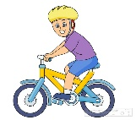
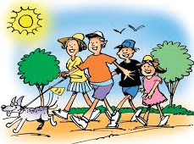
NOT AT THE BEACH

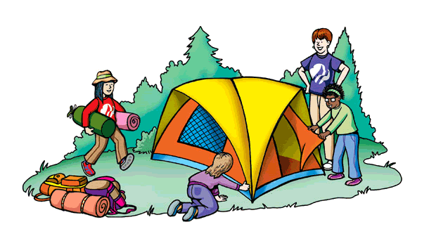

ANSWER KEY

I like / love summer holidays because it’s sunny and hot, I can …
My favourite outdoor activities are… / I like…
I don’t like… / I hate…

Outdoor activities:
At the beach: swimming, sailing, building sandcastles, surfing, playing volleyball
Not at the beach: riding a bike, hiking, camping, skateboarding, having a picnic

