Name: ____________________________ Surname: ____________________________ N^{ber}: ____ Grade/Class: _____
Assessment: _____________________________ | Date: ___________________________________________________
 | Teacher’s signature:  ___________________________ | Parent’s signature:  ___________________________

Look at the picture.
Answer the questions.

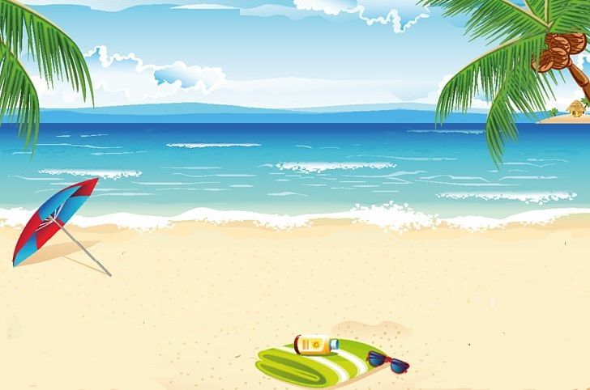

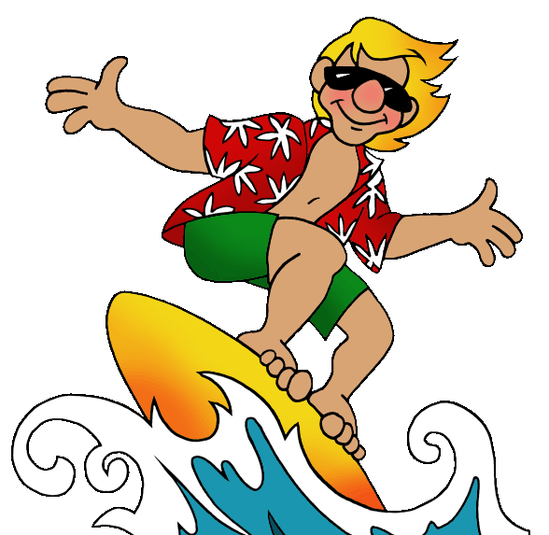

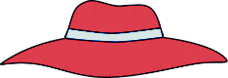
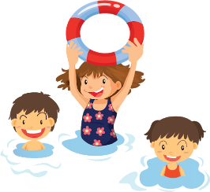
JACK
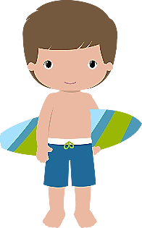
MIKE
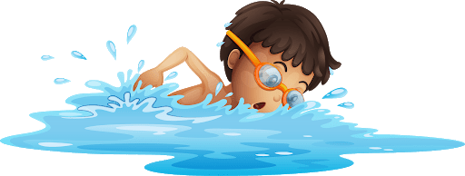

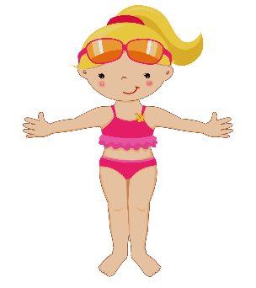
SAM

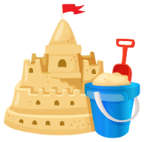

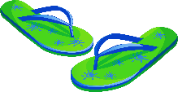
KATE

TEACHER’S QUESTIONS:

- Where are the people?
- What season is it?
- What‘s the weather like?
- How many children are in the sea?
- What is Mike doing? And Jack?
- What is Kate doing? What is she wearing?
- What is Sam wearing?
- Where are the flip flops?
- How many buckets/spades are there?
- What is your favourite summer activity?

ANSWER KEY

- They are at the beach.
- It’s summer.
- It’s sunny and very hot.
- There are five children in the sea.
- Mike is swimming and Jack is surfing.
- Kate is putting on sunscreen. She is wearing a swimsuit.
- Sam is wearing trunks.
- The flip flops are near kate.
- There are two buckets and two spades.
- My favourite summer activity is… swimming, sailing…

