Name: ____________________________ Surname: ____________________________ N^{ber}: ____ Grade/Class: _____
Assessment: _____________________________  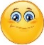  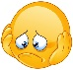  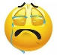 | Date: ___________________________________________________
 | Teacher’s signature:  ___________________________ | Parent’s signature:  ___________________________
- Complete and write. There is an example.

your her my their our his your

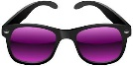
You’ve got s u n g l a s s e s They’re your sunglasses.
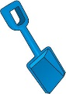
It’s _______ ________________.

It’s _______ ________________.

It’s _______ ________________.

It’s _______ ________________.

It’s _______ ________________.

They’re _______ ________________.

- I’ve got a s__ __d__.
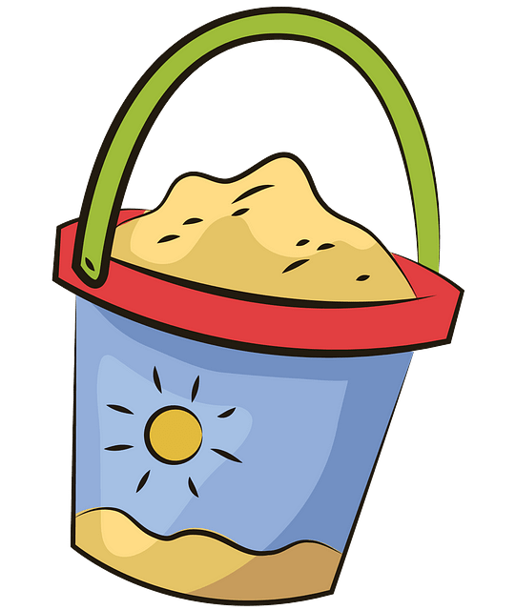
- We’ve got a b__ __k __ t.
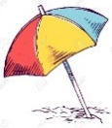
- They’ve got a b__ a __ h u__b__ e ll__.
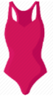
- She’s got a s__ __ m __ u __t.
- You’ve got a t__w__ l.
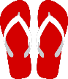
- He’s got f__ __ p f__ __ p__

- Circle the correct answer.

a) This is Emily’s / Emily ’ hat.
b) It’s the boy’s / boys’ sandcastle. It’s their sandcastle.
c) It’s Kevin’s / Kevin’ cap. It’s his cap.
d) That is my friends’ / friend’s sunscreen. It’s their sunscreen.
ANSWER KEY
EXERCISE 1
- I’ve got a spade – It’s my spade.
- We’ve got a bucket – It’s our bucket.
- They’ve got a beach umbrella – It’s their beach umbrella.
- She’s got a swimsuit – It’s her swimsuit.
- You’ve got a towel – It’s your towel.
- He’s got flip flops – It’s his flip flops.

EXERCISE 2
- Emily’s
- Boys’
- Kevin’s
- Friends’

