Name: ____________________________ Surname: ____________________________ N^{ber}: ____ Grade/Class: _____
Assessment: _____________________________  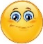  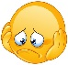  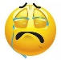 | Date: ___________________________________________________
 | Teacher’s signature:  ___________________________ | Parent’s signature:  ___________________________

Answer the questions. There is an example.

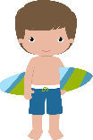
This is Brian’s towel.
Whose towel is this?
a)
Brian
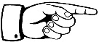
b)
Whose bucket is this?
____________________________
Mary
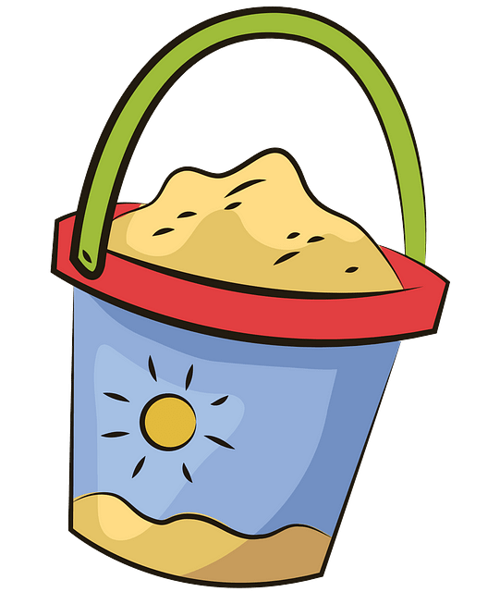

Whose beach umbrella is that?

c)
____________________________
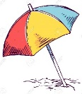
my parents

d)
Whose flip flops are these?
____________________________

boys
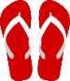
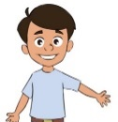
____________________________

Whose sunglasses are those?
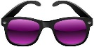
e)
Whose spade is this?
Rose
Jack

f)
____________________________

ANSWER KEY

b) This is Mary’s bucket.
c) That is my parents’ beach umbrella.
d) These are the boys’ flip flops.
e) Those are Jack’s sunglasses.
f) This is Rose’s spade.

