Name: ____________________________ Surname: ____________________________ N^{ber}: ____ Grade/Class: _____
Assessment: _____________________________  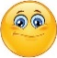  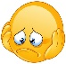  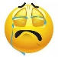 | Date: ___________________________________________________
 | Teacher’s signature:  ___________________________ | Parent’s signature:  ___________________________

Look at the pictures, unscramble and write.
s g u l s
n a s e s
o t
w e l
a e
s

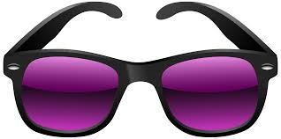

- ______________ b) _______________ c) ________________

s u r e c
n s e n
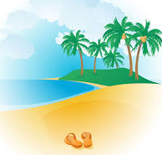
c b h
a e
a s
n d
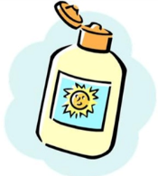
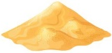

d) _______________ e) ________________ f) ________________

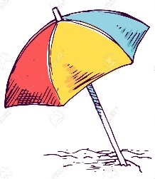
e s p
a d
c b u
k t e
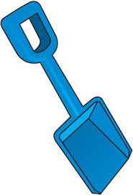
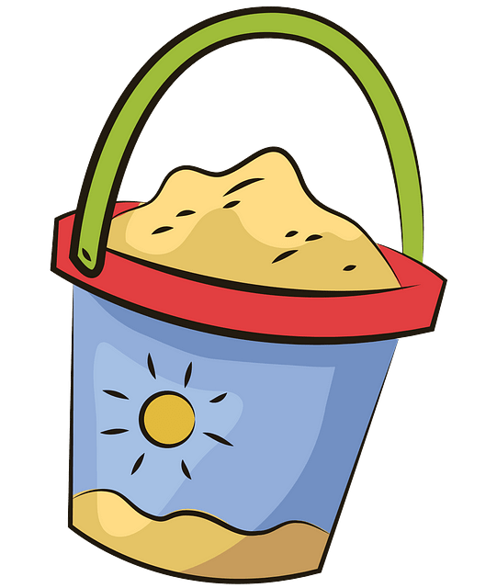
c b h a e
u b r e l l m a

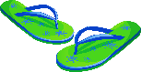
g) _______________ h) ________________ i) _________ ___________

f i l p
s f p o l d
s w u t
m i s i

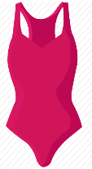
h t
a
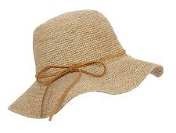
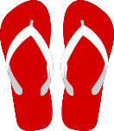

j) _______________ k) ________ _________ l) ________________

ANSWER KEY

- Towel
- Sea
- Sunglasses
- Beach
- Sand
- Sunscreen
- Bucket
- Spade
- Beach umbrella
- Hat
- Flip flops
- Swimsuit

