Name: ____________________________ Surname: ____________________________ N^{ber}: ____ Grade/Class: _____
Assessment: _____________________________ | Date: ___________________________________________________
 | Teacher’s signature:  ___________________________ | Parent’s signature:  ___________________________

Write and match.
S _ i _ m _ _ g
P_ _ y _ _ g
v _ l l _ y_ a _ _
S u _ f _ _ g
S _ _ l i _ g
B_ _ ld _ _ g a
s _ n _ c_ s t _ _

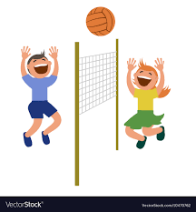
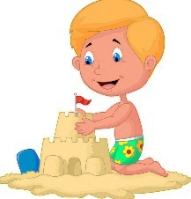
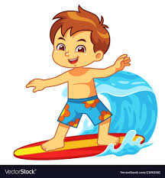
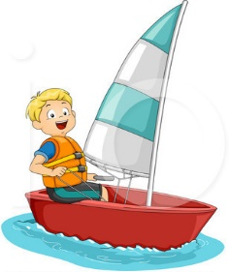
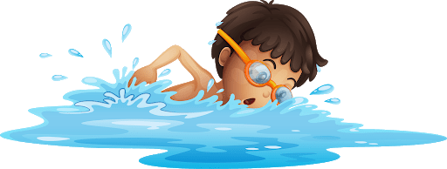

H _ v _ n _
a p _ _ n _ _
R _ d _ _ g
a b _ k _
_k_t_b_a_d _ _g
C _ _ p _ n _
G _ i _ g f _ _
a w _ _ k

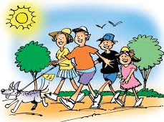
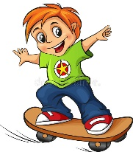
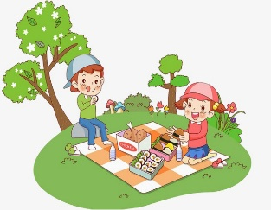
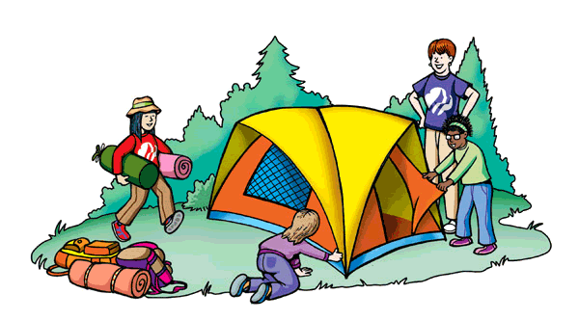
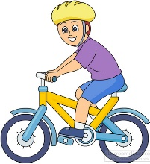

ANSWER KEY
Swimming
Playing volleyball
Surfing
Sailing
Building sandcastles

Having a picnic
Riding a bike
Skateboarding
Camping
Going for a walk

