Name: ____________________________ Surname: ____________________________ N^{ber}: ____ Grade/Class: _____
Assessment: _____________________________  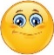 | Date: ___________________________________________________
 | Teacher’s signature:  ___________________________ | Parent’s signature:  ___________________________
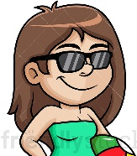
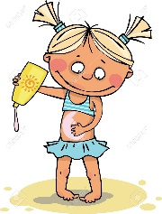
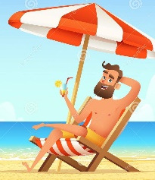
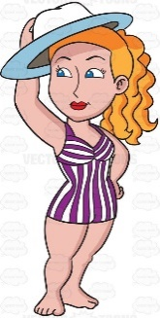
- Complete the advice for sun safety. Then match.
C
B
A
E

- P__ __ on s__n__ __ r __ __ n

- W__ __ r a h__ __

- W __a__ s__ __ g __ __s__ __ s

D

- S__ __ y u__ d __ r the b__ __ c __ u__ b__ __ l __ __

- W e __ __ a T-__ __ i __t

- Circle the correct option. Then match.
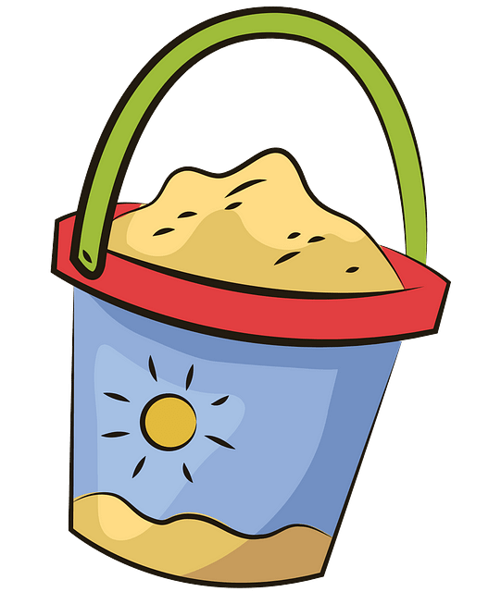
- You’ve got a blue bucket. It’s your / his bucket.
- They’ve got a towel. It’s their / my towel.
- We’ve got a spade. It’s our / her spade.
- He’s got flip flops. They’re his / your flip flops.
- She’s got a swimsuit. It’s their / her swimsuit.
- I’ve got a cap. It’s your / my cap.

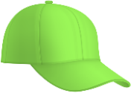
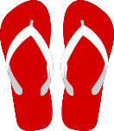

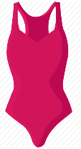
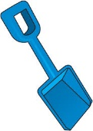

ANSWER KEY
EXERCISE 1
- Put on sunscreen – D
- Wear a hat – A
- Wear sunglasses – E
- Stay under the beach umbrella – B
- Wear a T-shirt – C

EXERCISE 2
- your
- their
- our
- his
- her
- my

