|  |  |  |
| --- | --- | --- |
| **TOPIC: Seasons** | **SUBTOPICS: vocabulary related to summer** | **LEVEL: A2** |
| **Name:** ____________________________ **Surname:** ____________________________ **Nber: ____ Grade/Class:** _____ | | |

**Summer**

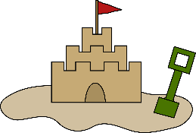**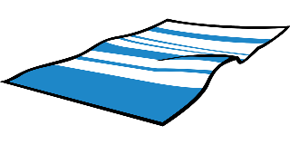Match.**

Beach

Sandcastle

Sea

Towel

Sand

Sunscreen

Seashell

Spade

Bucket

Swimsuit

Beach umbrella

Cap

Hat

Flip flops

Sunglasses

Boat



