Name: ____________________________ Surname: ____________________________ N^{ber}: ____ Grade/Class: _____
Assessment: _____________________________ | Date: ___________________________________________________
 | Teacher’s signature:  ___________________________ | Parent’s signature:  ___________________________

- Look and write about Jason and Kate’s likes and dislikes concerning outdoor activities.

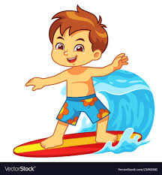
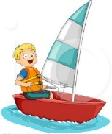

a) Jason ___________ s__ __ l __ __ g but he ___________ s__ __ f __ n __
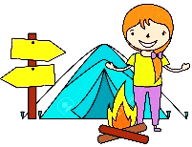

b) Kate __________ h__v__ __ __ a p__ __n__ __ but she ___________ c__m__ __ __ __

- And you? Write about the outdoor activities you like and don’t like. Then draw.
I _____________________________________ but I ________________________________

ANSWER KEY
1)
a) Jason likes sailing but he doesn’t like surfing.
b) Kate likes having a picnic but she doesn’t like camping.

2)
I like… (e.g. riding a bike) but I don’t like… (e.g. skateboarding)

