Name: ____________________________ Surname: ____________________________ N^{ber}: ____ Grade/Class: _____
Assessment: _____________________________ | Date: ___________________________________________________
 | Teacher’s signature:  ___________________________ | Parent’s signature:  ___________________________

Read and complete the letter.

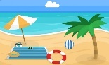
Hello grandma!
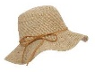
How are you? We’re great. We’re on our summer holidays at the (1) b _ _ c _ . We’re having so much fun!
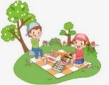
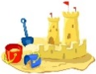
It’s very (2) h _ _ , we always have to wear a (3) h _ _ and put on (4) s _ _ s _ _ e _ _ I love (5) s _ _ _ m _ _ g in the sea and building (6) s _ _ d _ _ _t _ _ s . Ryan’s got a new favourite activity: (7) s _ _ f _ _ _ , but he isn’t very good at it.
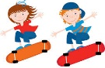
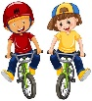
At lunch time, we go to the park for a (8) p _ _ n _ _ . Then we like (9) r_ d _ _ g a b_ _ e ______or (10) s_ _ t _ b _ _ r _ _ n _ .
We miss you a lot!
See you soon,
Laura and Ryan

ANSWER KEY
- Beach
- Hot
- Hat
- Sunscreen
- Swimming
- Sandcastles
- Surfing
- Picnic
- Riding a bike
- Skateboarding

