Name: ____________________________ Surname: ____________________________ N^{ber}: ____ Grade/Class: _____
Assessment: _____________________________  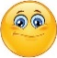  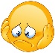  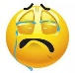 | Date: ___________________________________________________
 | Teacher’s signature:  ___________________________ | Parent’s signature:  ___________________________

Look at the picture and answer the questions.

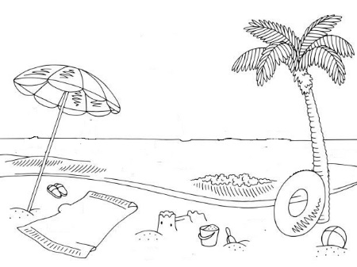
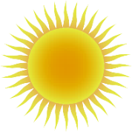

Jack
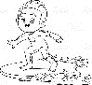
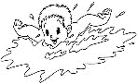
Paul

- _______________________________________
- _______________________________________
- _______________________________________
- _______________________________________
- _______________________________________
- _______________________________________
- _______________________________________
a) What season is it?
b) What’s the weather like?
c) What is Paul doing?
d) What is Jack doing?
e) What is under the beach umbrella?
f) What is near the bucket?
g) Where is the hat?

ANSWER KEY
- It’s summer.
- It’s sunny and very hot.
- Paul is swimming.
- Jack is surfing.
- There is a towel under the beach umbrella.
- There is a spade near the bucket.
- The hat is on the towel.

