Name: ____________________________ Surname: ____________________________ N^{ber}: ____ Grade/Class: _____
Assessment: _____________________________ | Date: ___________________________________________________
 | Teacher’s signature:  ___________________________ | Parent’s signature:  ___________________________

- Separate the words and write 5 advice for sun safety. Then match.

- _________________________________.
- _________________________________.
- _________________________________.
- _________________________________.
- _________________________________.
- Putonsunscreen
- Wearahat
- WearaT-shirt
- Wearsunglasses
- Stayunderthebeachumbrella
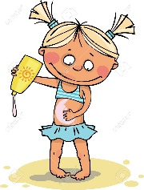
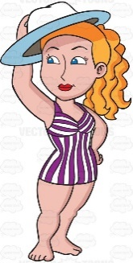
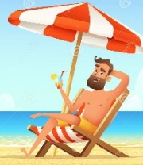
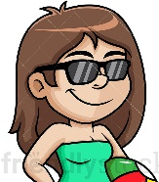

- Put the words in order.
- _________________________________.
- _________________________________.
- _________________________________.
- _________________________________.
- _________________________________.
a) towel / whose / is / that / ?
b) is / this / her / swimsuit / .
c) the / it’s / bucket / boys’ / .
d) Anne’s / these / are / flip flops / .
e) under / the / beach umbrella / is / spade / the / .

ANSWER KEY

1)
a) Put on sunscreen.
b) Wear a hat.
c) Wear a T-shirt.
d) Wear sunglasses.
e) Stay under the beach umbrella.

2)
a) Whose towel is that?
b) This is her swimsuit.
c) It’s the boy’s bucket.
d) These are Anne’s flip flops.
e) The spade is under the beach umbrella.

