Exercise Shopping A2
Name: ____________________________ Surname: ____________________________ N^{ber}: ____ Grade/Class: _____
Assessment: _____________________________  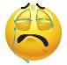  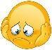  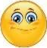 | Date: ___________________________________________________
 | Teacher’s signature:  ___________________________ | Parent’s signature:  ___________________________

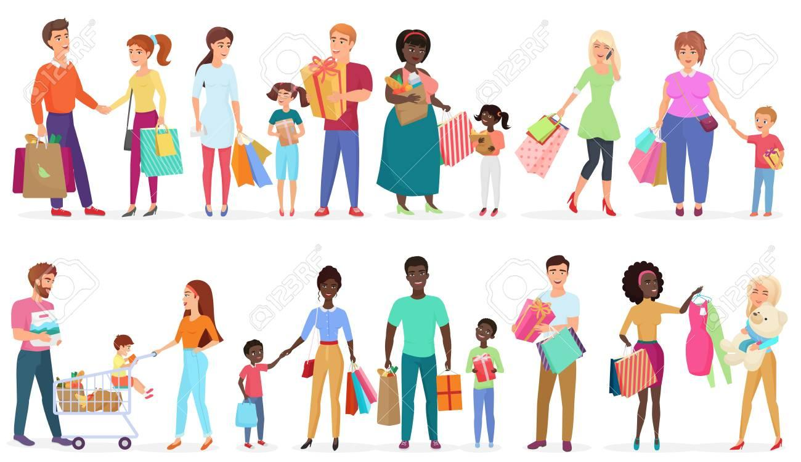

When you go shopping, what can you buy from the following shops?
Write only one word:
e.g. Dairy shop milk

- Supermarket -------------
- Bookstore -------------
- Bakery -------------
- Sweet shop -------------
- Sports shop -------------
RUBRICS
Task Achievement - Two points for each acceptable answer given (10 Marks)
Excellent: 8-10 🙂👏
Very Good: 5-7 🙂
Satisfactory: 2-4 😐
Unsatisfactory: 0-2 ☹️

Language (Spelling) - Two points for each correctly spelled answer given (10 Marks)
Excellent: 8-10 🙂👏
Very Good: 5-7 🙂
Satisfactory: 2-4 😐
Unsatisfactory: 0-2 ☹️

Key

Accept any of the following answers
- Any type of fruit-vegetable- food
- Books, magazines, pens, pencils, maps, cards , school bags
- Bread, biscuits, cookies, sweets, cakes
- Sweets, cakes, cookies, biscuits, birthday cakes,
- Trainers, sneakers, t-shirts, balls, track-suits

