Exercise 1 A1 Shopping
Name: ____________________________ Surname: ____________________________ N^{ber}: ____ Grade/Class: _____
Assessment: _____________________________ | Date: ___________________________________________________
 | Teacher’s signature:  ___________________________ | Parent’s signature:  ___________________________

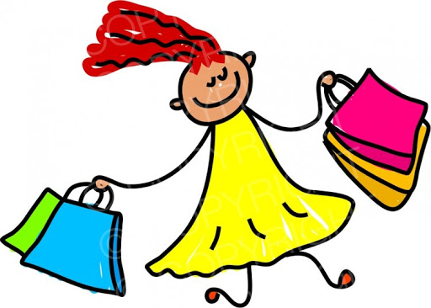

Lisa is very happy because she went shopping and bought a lot of things. Listen and tick the things she bought.
There is one example: shirt √

- Shoes ---------

- Dress ---------

- T-shirt ---------

- Socks ---------

- Hat --------

Key: You tick 1, 3, 5

Transcript:
Lisa is very happy today. She went shopping with her mum and bought lots of things.
She bought a nice red shirt and a lovely yellow T-shirt.
She also got a pair of black shoes, jeans and a brown jacket. She got a funny green hat, too!!

