Ex A1 Shopping
Name: ____________________________ Surname: ____________________________ N^{ber}: ____ Grade/Class: _____
Assessment: _____________________________  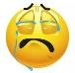  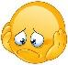  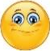  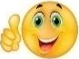 | Date: ___________________________________________________
 | Teacher’s signature:  ___________________________ | Parent’s signature:  ___________________________

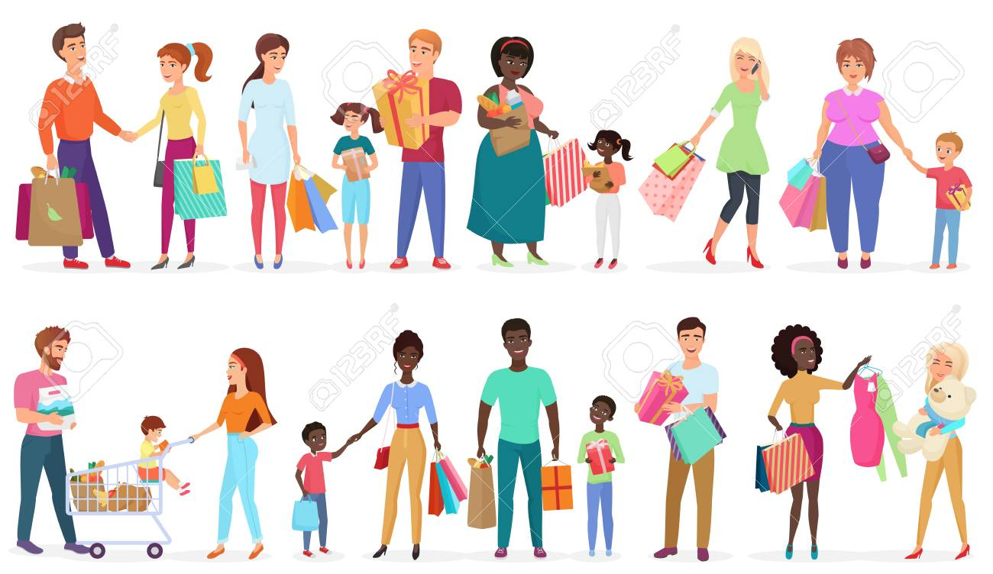

Listen and write in the gaps what you can buy from these shops:

Bread, cakes, milk, shoes, books, toys, pets, flowers.

Write the word from the above list next to the shop you can buy them.
e.g. Florist flowers
1. Bakery --------------
2. Sweet shop ---------------
3. Dairy shop -------------
4. Toy shop --------------
5. Pet shop --------------
6. Bookshop --------------
7. Shoe shop --------------

Transcript:

When we need to buy flowers we go to a florist’s
We buy pets from a pet shop, bread from bakery and shoes from a shoe shop.
We can get milk from a dairy shop, books from a bookstore and cakes from a sweet shop.
Also, we can buy toys from a toy shop.

