Exercise 3 A1 shopping
Name: ____________________________ Surname: ____________________________ N^{ber}: ____ Grade/Class: _____
Assessment: _____________________________  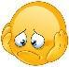  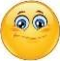  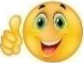 | Date: ___________________________________________________
 | Teacher’s signature:  ___________________________ | Parent’s signature:  ___________________________

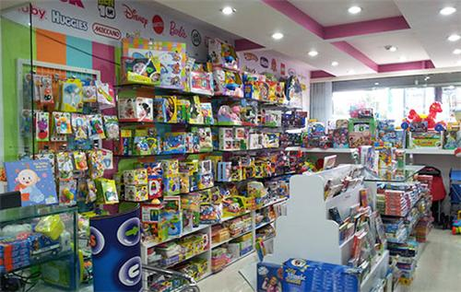
Read the following text and answer the questions

Mum and Tom are at the toy shop and they are looking at the toys. The shop is very big. There are a lot of kids at the shop. There are so many beautiful things in there.
“Do you like this lovely red ball?” Mum asks Tom “Yes, I like it very much!” answers Tom
“Good!” says Mum “It’s your present!” “Thank you Mum, I love you!” says Tom and kisses his Mum.
Complete the sentences. Use: shop/ looking/ big/ present
Mum and Tom are at a toy ---------- . The shop is -------------
They are ----------------- at the toys . It is a ------------------ for you
Answer yes or no
The shop is small -------. There are a lot of kids in the shop -------.
Mum and Tom are looking at the kids ------.

Key: 1. Shop 2. Big 3. Looking 4. Present
- No 2 yes 3. no

