Ex.4 A1 Shopping
Name: ____________________________ Surname: ____________________________ N^{ber}: ____ Grade/Class: _____
Assessment: _____________________________ | Date: ___________________________________________________
 | Teacher’s signature:  ___________________________ | Parent’s signature:  ___________________________

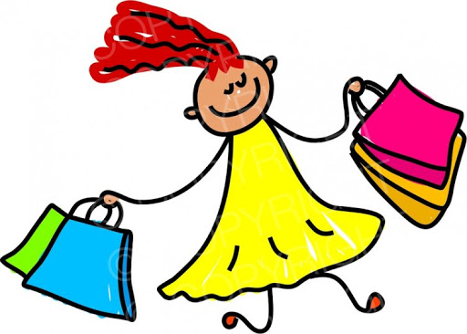
Read and write what Hellen got from the shopping mall today:

Hellen’s Shopping Day
It was wonderful at the mall today, I got so many things that I really liked.
I bought 4 T-shirts, 1 hat, 2 skirts, a lovely pair of shoes and a fantastic pair of shorts.
I often go with my mum shopping on Saturdays. Then, I meet my friends and hang out together. I am so happy about my shopping.

Write what Hellen got from the shopping mall today:
Hellen got -------------------------------------------------------------------------------------------------------------------------------------------------------------------------------------------------------------------------------------

