Ex. 5 A1 Shopping
Name: ____________________________ Surname: ____________________________ N^{ber}: ____ Grade/Class: _____
Assessment: _____________________________ | Date: ___________________________________________________
 | Teacher’s signature:  ___________________________ | Parent’s signature:  ___________________________

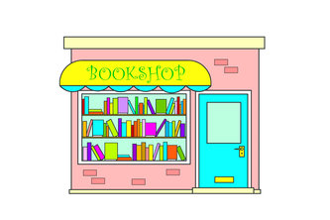

Read the text fill in the gaps with the right word.

Peter went to the local open-air market today and bought lots of fruit.
He got 4 apples, 6 lemons, 7 oranges and 3 bananas.
He also got cherries, strawberries and grapes. Then he went to the bookshop to buy 2 books for his English lessons. After that, he visited the local pet shop to buy a parrot for his sister Sheila because she loves birds.
It was a tiring day.

Peter went to the local open-air market today and bought lots of fruit.
He got ----------------------, 6 lemons, --------------------- and 3 bananas.
He also got ----------------------, strawberries and --------------------
Then he went to the -------------------------- to buy 2-----------------.
After that he went to the ---------------------- to buy a parrot.

