TOPIC: Shopping | SUBTOPICS: Reading(Scanning) - Vocabulary | LEVEL: A1
Name: ____________________________ Surname: ____________________________ N^{ber}: ____ Grade/Class: _____

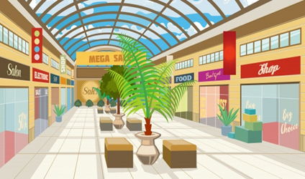

Mary’s Shopping

Mary went to the shopping mall yesterday. She bought lots of things. She bought a pair of jeans and 3 T-shirts but she didn’t buy a jacket as it was very expensive. Also, she got a new pair of sunglasses.

When she left the mall, she realized that she had forgotten to buy a present for her friend Tom who had his birthday yesterday but she bought a nice birthday card for him on the way home.

Now write down what Mary bought, didn’t buy or forgot to buy from the mall.

e.g. She bought jeans
1. She bought ---------------------------------------------
2. She didn’t buy --------------------------------------------
3. She bought ----------------------------------------------
4. She also got -----------------------------------------------
5. She forgot to buy ------------------------------------------------

KEY
- 3-T-shirts 2. A jacket 3. A pair of sunglasses 4. A birthday card 5. A present for Tom

