Ex. 1 A2 Shopping
Name: ____________________________ Surname: ____________________________ N^{ber}: ____ Grade/Class: _____
Assessment: _____________________________ | Date: ___________________________________________________
 | Teacher’s signature:  ___________________________ | Parent’s signature:  ___________________________

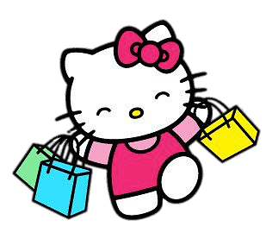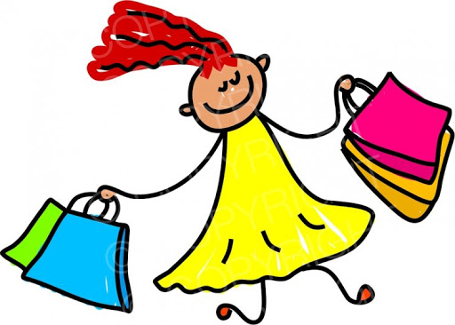

When we go shopping, we are very happy because we buy a lot of things we like for our family, friends and ourselves.

Can you tell me what can you buy from a bakery?
What can you buy from a dairy shop?
What can you buy from a toy shop?
What can you buy from a sports shop?

