Ex2 A1 Shopping
Name: ____________________________ Surname: ____________________________ N^{ber}: ____ Grade/Class: _____
Assessment: _____________________________ | Date: ___________________________________________________
 | Teacher’s signature:  ___________________________ | Parent’s signature:  ___________________________
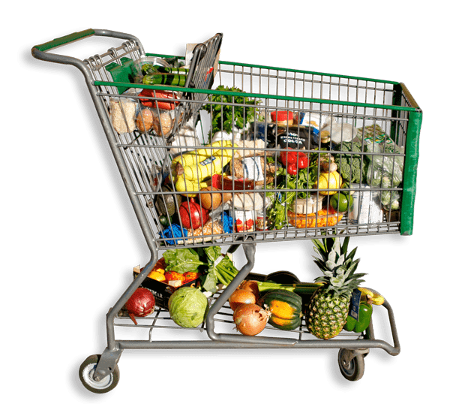
Can you tell me the differences between these two pictures?

