Ex.3 A1 Speaking
Name: ____________________________ Surname: ____________________________ N^{ber}: ____ Grade/Class: _____
Assessment: _____________________________ | Date: ___________________________________________________
 | Teacher’s signature:  ___________________________ | Parent’s signature:  ___________________________

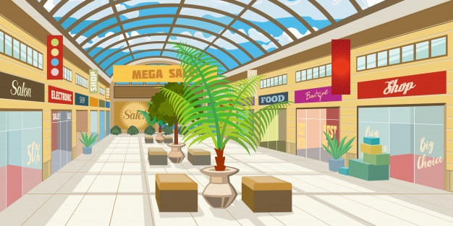

This is a new shopping mall in my town.

What shops can you find in a shopping mall? E.g. sports shops
Do you like going to shopping malls?

