Ex 4 A1 Shopping
Name: ____________________________ Surname: ____________________________ N^{ber}: ____ Grade/Class: _____
Assessment: _____________________________ | Date: ___________________________________________________
 | Teacher’s signature:  ___________________________ | Parent’s signature:  ___________________________

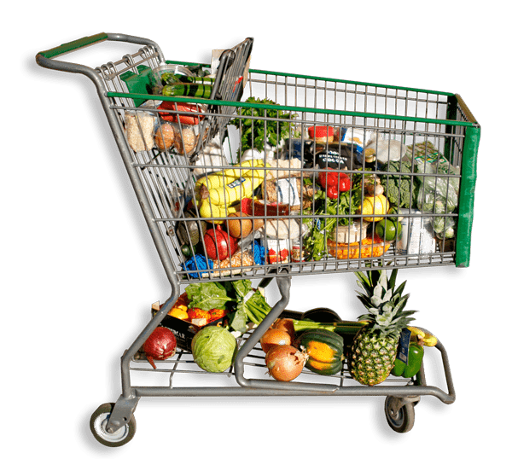

This is a shopping trolley in a supermarket full of things.

Can you tell me if there are any supermarkets in your area?
What do like about going shopping to a supermarket?
What do you dislike about going shopping to a supermarket?
Do you like going shopping to a mall ? Why/Why not?

