Ex. 5 A2 shopping
Name: ____________________________ Surname: ____________________________ N^{ber}: ____ Grade/Class: _____
Assessment: _____________________________ | Date: ___________________________________________________
 | Teacher’s signature:  ___________________________ | Parent’s signature:  ___________________________

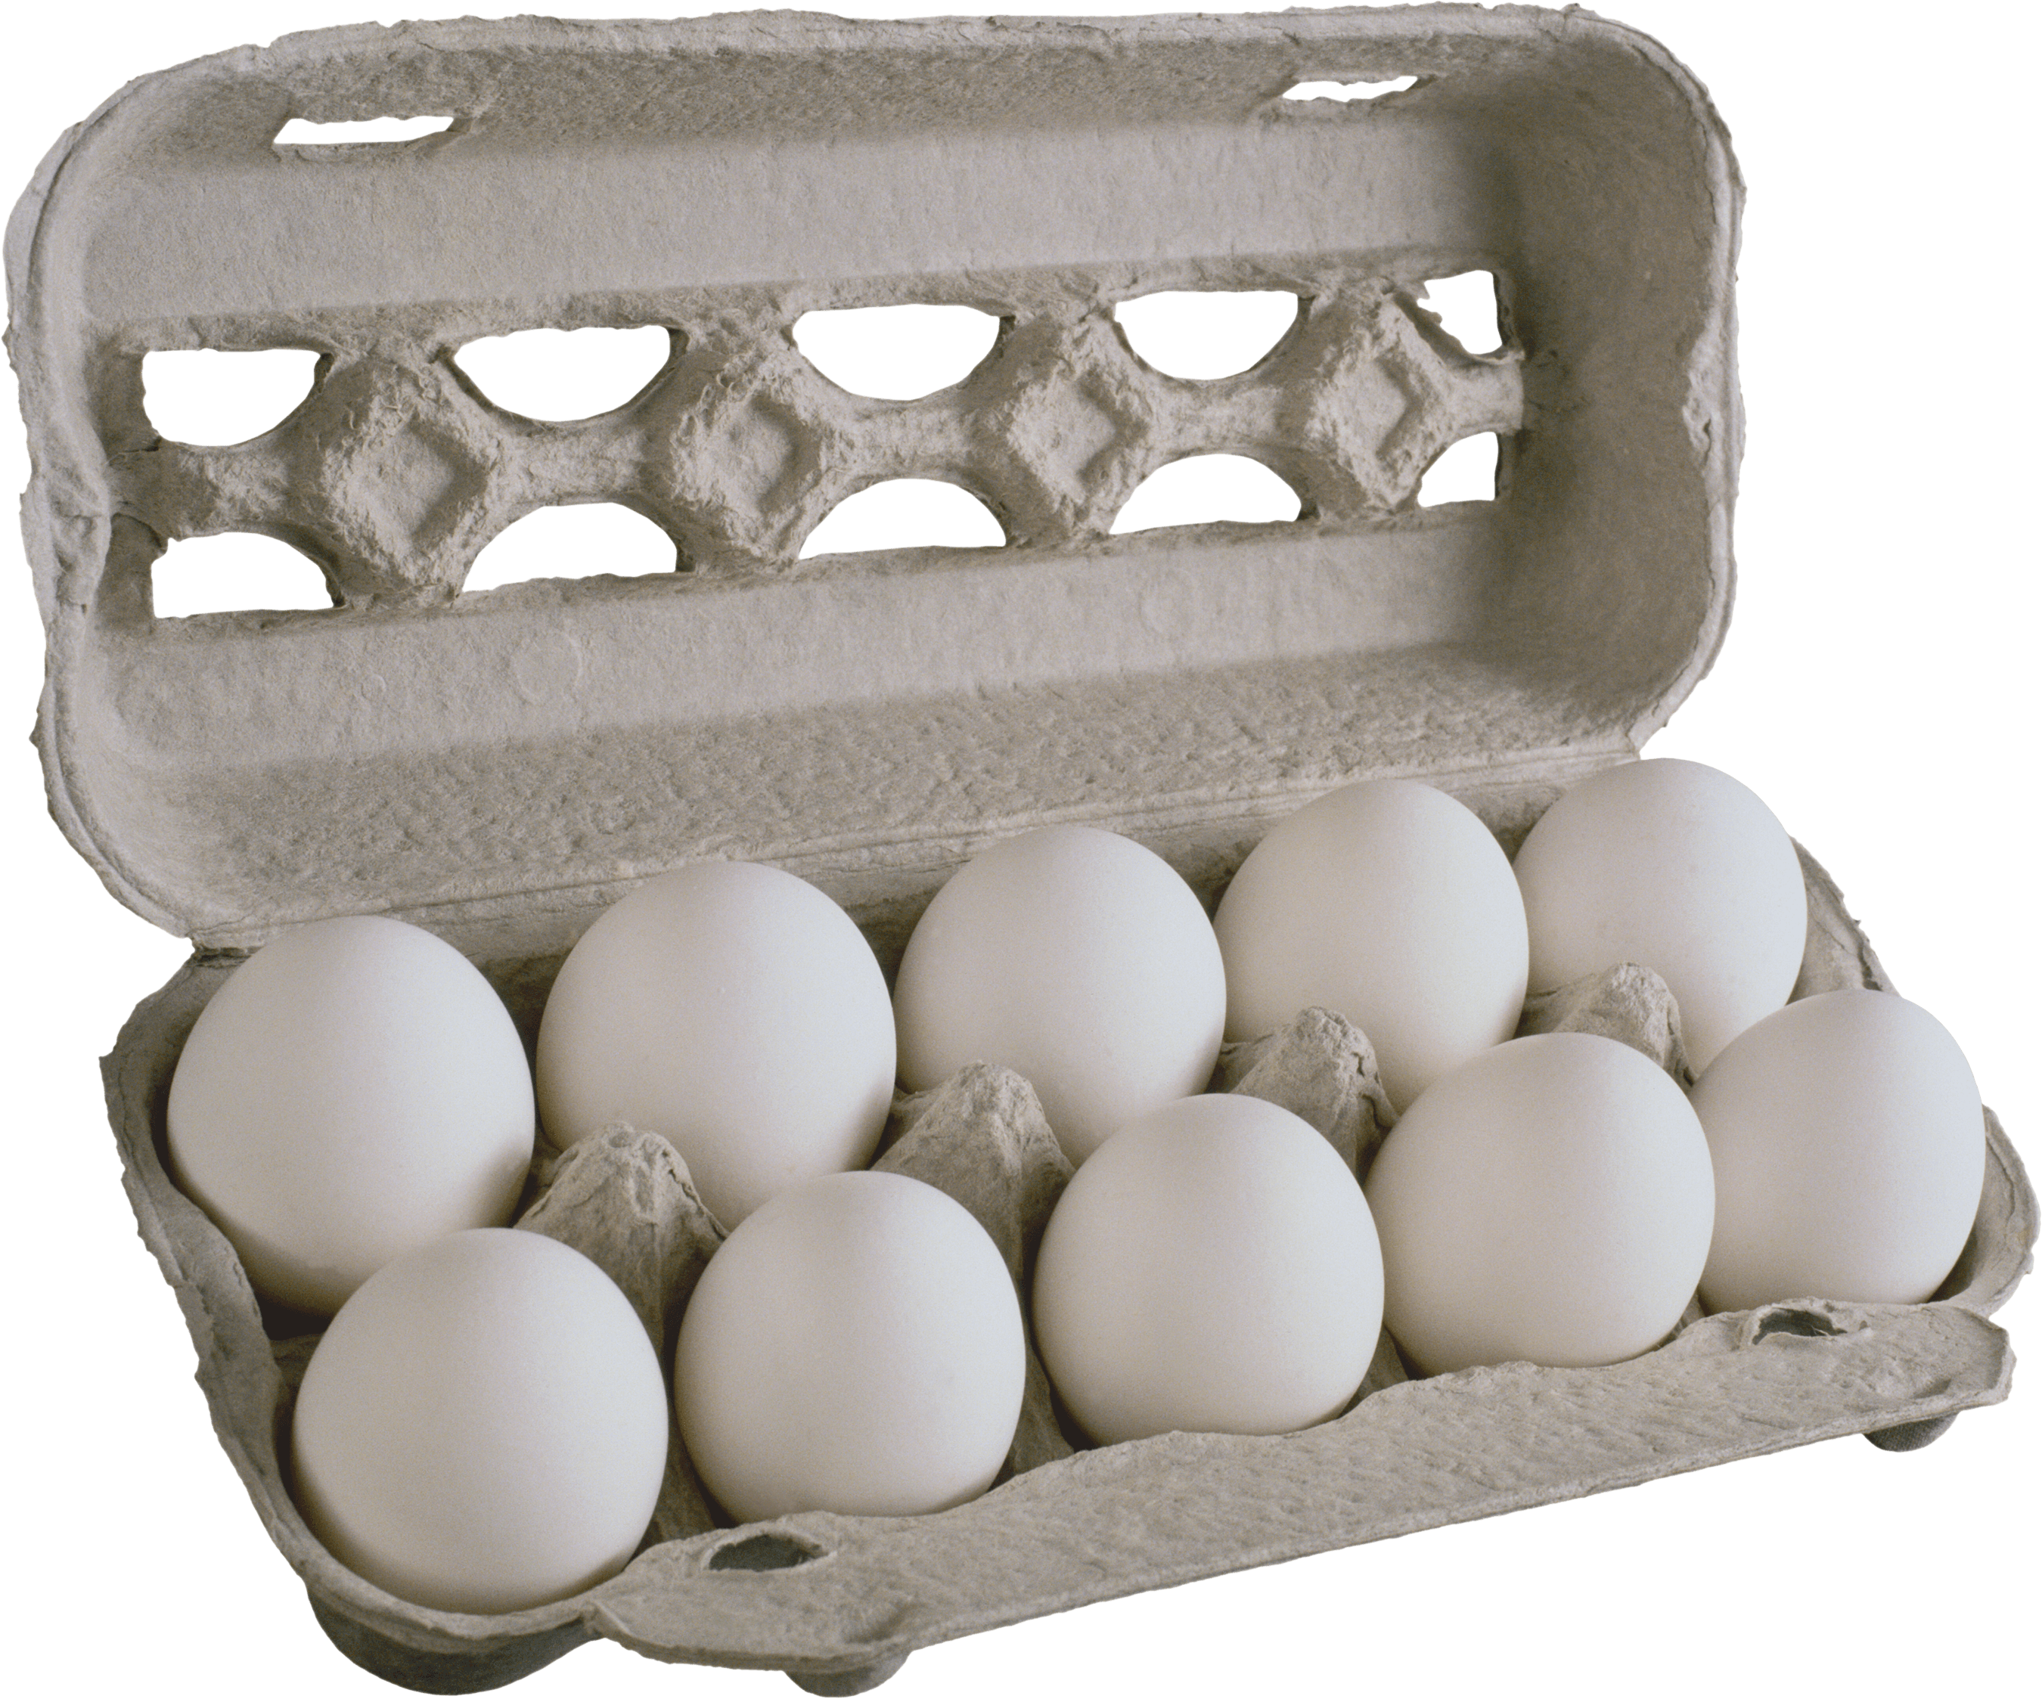
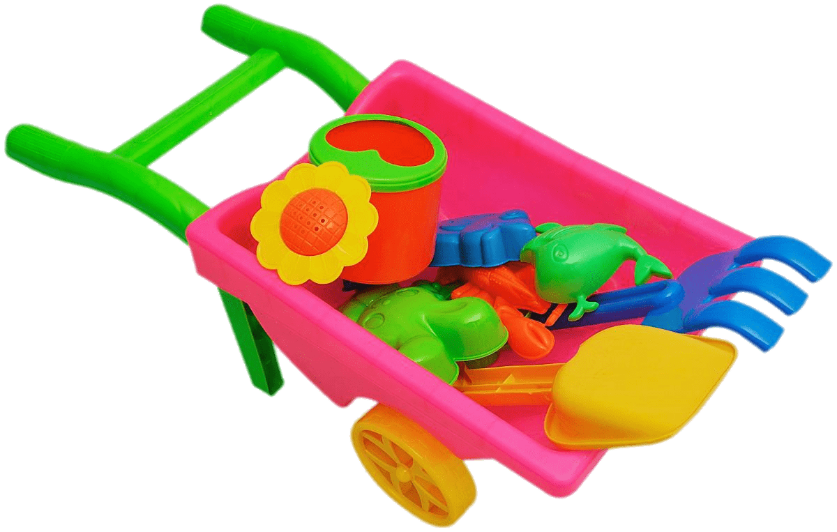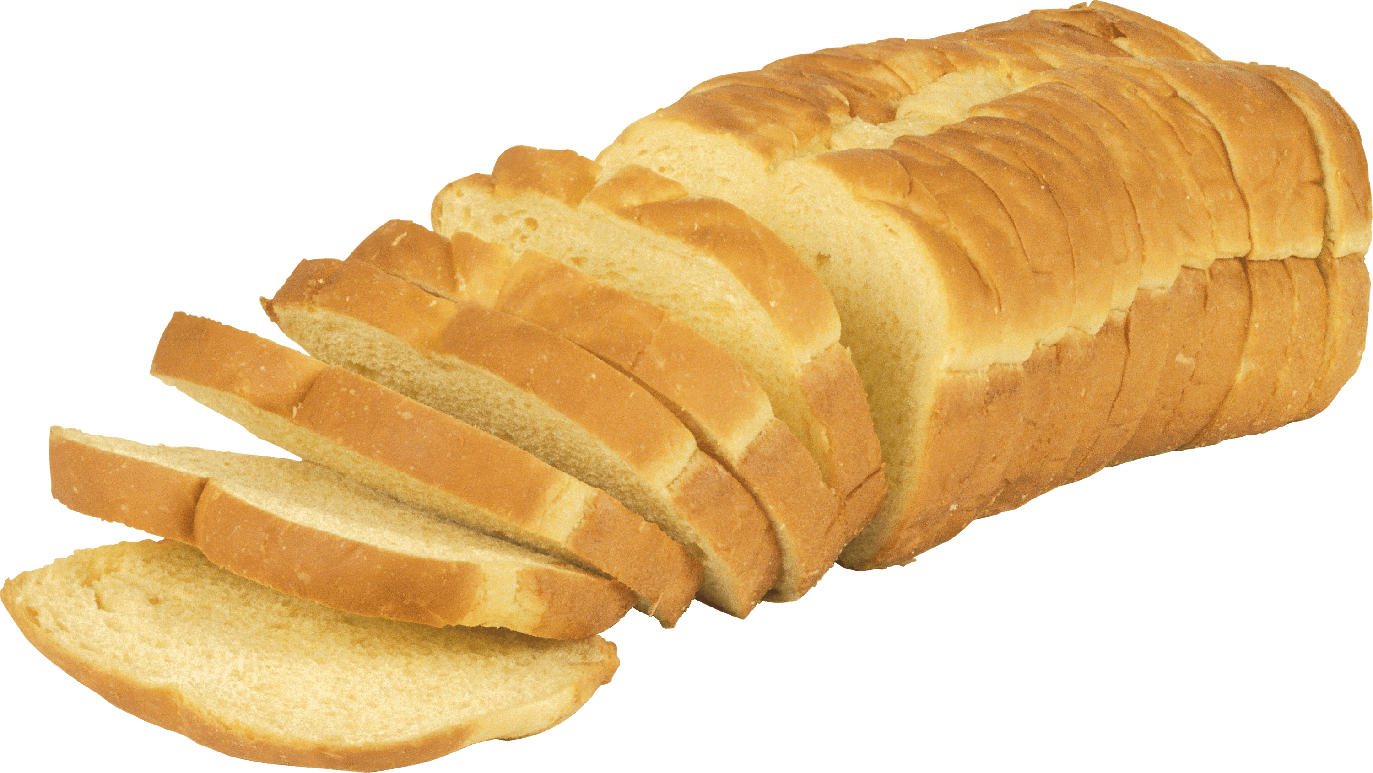

Which picture is the odd one out and does not match with the others? Why?

