Ex. 2 A1 Shopping
Name: ____________________________ Surname: ____________________________ N^{ber}: ____ Grade/Class: _____
Assessment: _____________________________  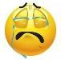  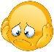  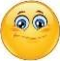 | Date: ___________________________________________________
 | Teacher’s signature:  ___________________________ | Parent’s signature:  ___________________________

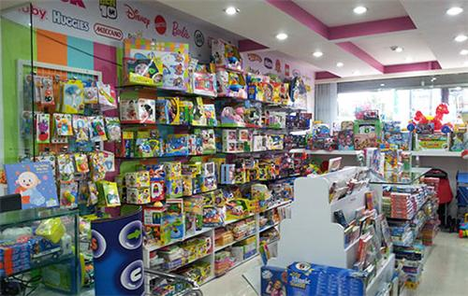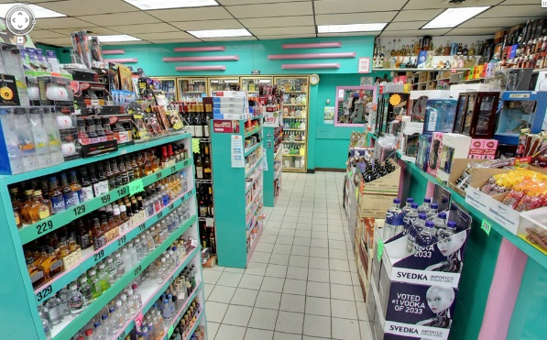

Write the things you can buy next to the shops. Choose from the list.

Bread, a birthday cake, milk, shoes, books, toys, a puppy, flowers.

1. Bakery --------------
2. Sweet shop ---------------
3. Dairy shop ---------------
4. Toy shop --------------
5. Pet shop --------------
6. Bookshop --------------
7. Shoe shop --------------
8. Florist’s --------------

