Ex.3 A1 Shopping
Name: ____________________________ Surname: ____________________________ N^{ber}: ____ Grade/Class: _____
Assessment: _____________________________ | Date: ___________________________________________________
 | Teacher’s signature:  ___________________________ | Parent’s signature:  ___________________________

Where can you find these things? Draw a line to match them with the shops.
1. Bakery
2. Sweet shop
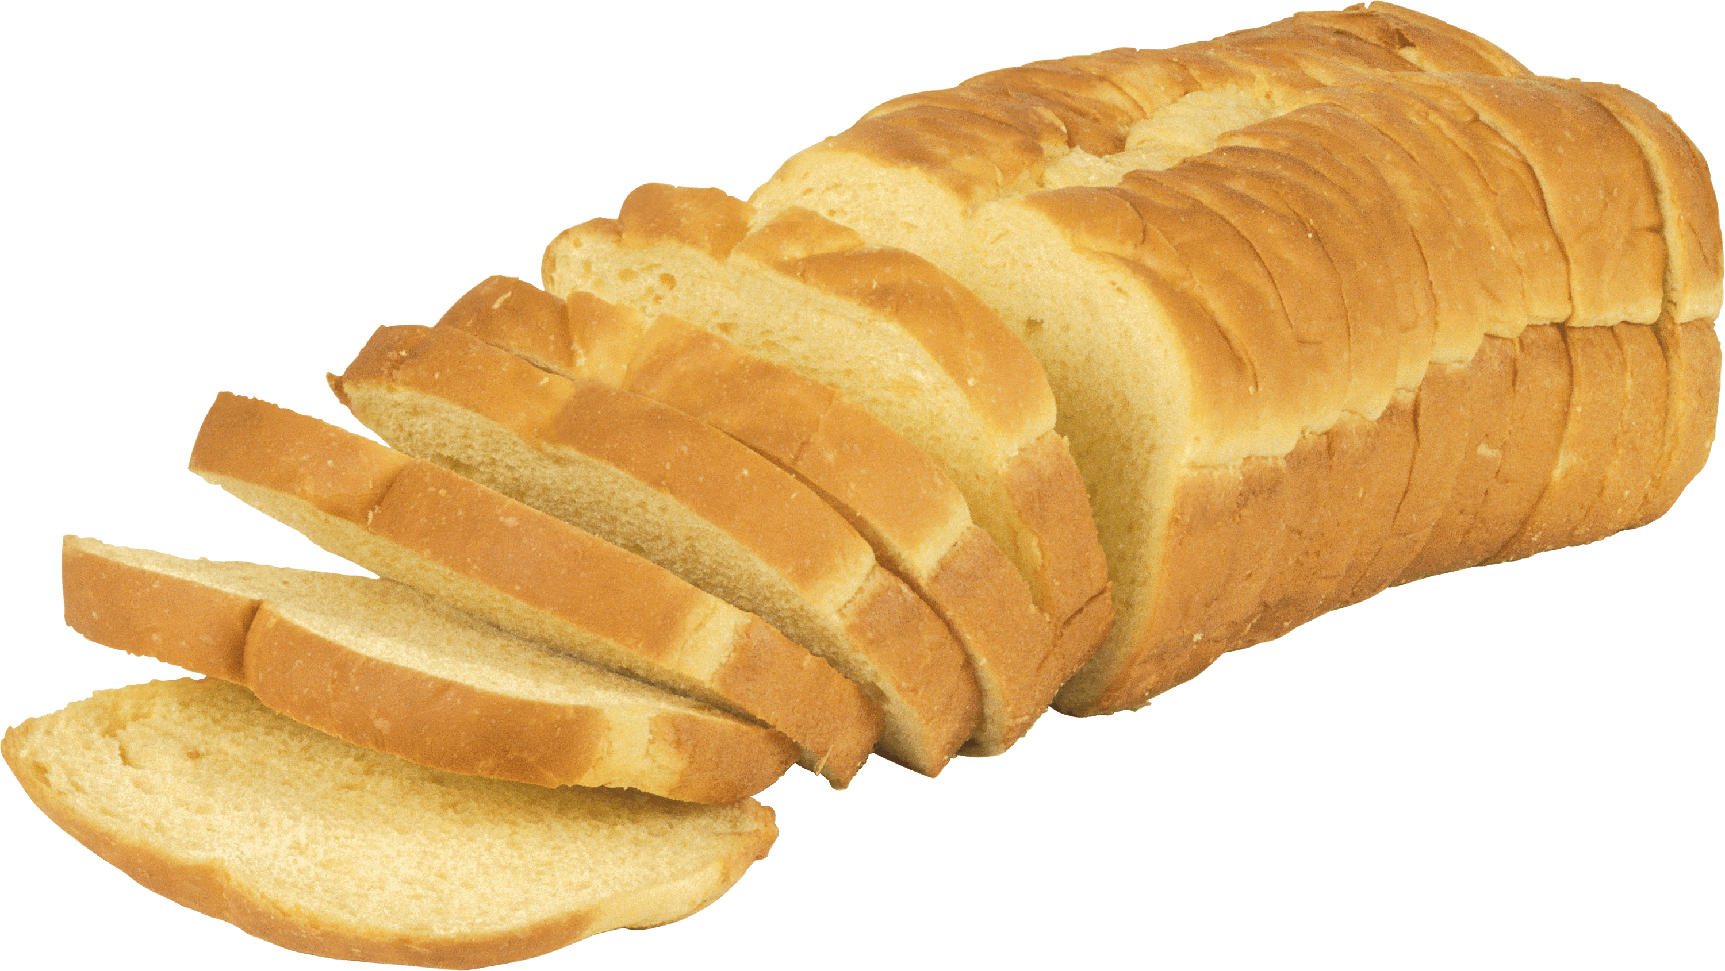 3. Café

