Ex.4 A1 Shopping
Name: ____________________________ Surname: ____________________________ N^{ber}: ____ Grade/Class: _____
Assessment: _____________________________ | Date: ___________________________________________________
 | Teacher’s signature:  ___________________________ | Parent’s signature:  ___________________________

Where can you get these things? Write the name of the shop next to the picture. Choose from the list.
Greengrocer/ bookstore / toy shop/ / florist’s/ pet shop/sweet shop

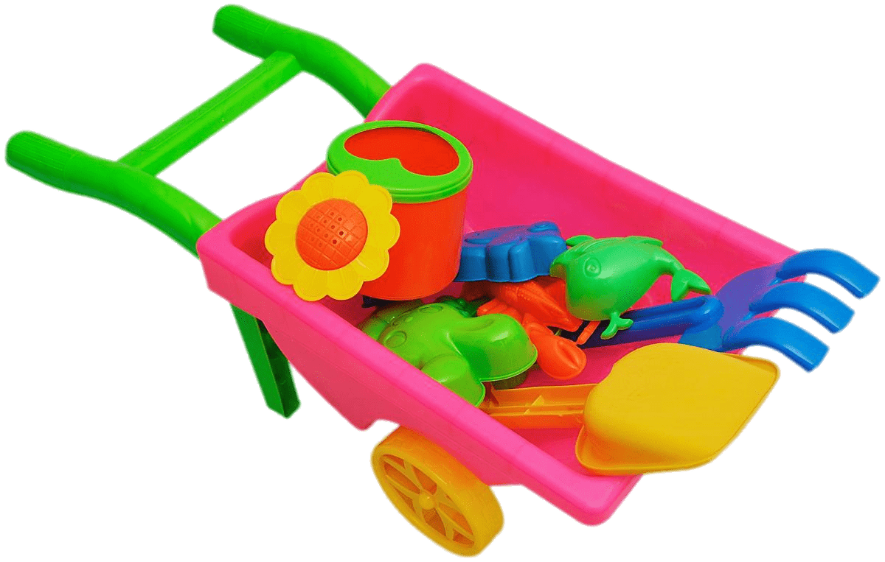 1. ________________________
2. _______________________
3. _________________________

