Ex.5 A1 Shopping
Name: ____________________________ Surname: ____________________________ N^{ber}: ____ Grade/Class: _____
Assessment: _____________________________ | Date: ___________________________________________________
 | Teacher’s signature:  ___________________________ | Parent’s signature:  ___________________________

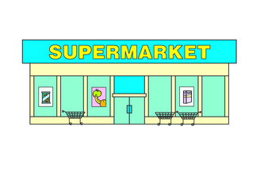
Shops: Greengrocer/ bookstore / toy shop/ florist’s/ pet shop/sweet shop/ supermarket

Answer with YES or NO
- Are there all these shops in the area you live in? ----------------------
- Do you go shopping every week? ----------------------

Write 5 shops that there are in your area:
1._______________________2.____________________3.______________________4.______________________________5.____________________________________

