TOPIC: Shopping | SUBTOPICS: Vocabulary | LEVEL: A1
Name: ____________________________ Surname: ____________________________ N^{ber}: ____ Grade/Class: _____

Draw lines to match the food in the photos with the shop you can get them from:

Greengrocer

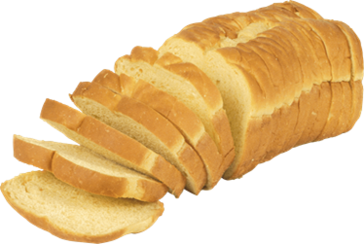 Sweet shop

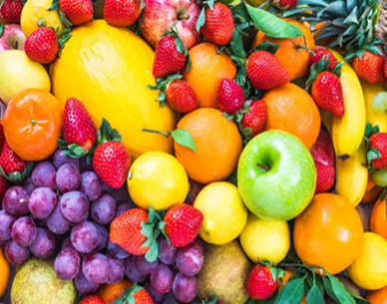 Bakery

