Ex. 5 A1 Shopping
Name: ____________________________ Surname: ____________________________ N^{ber}: ____ Grade/Class: _____
Assessment: _____________________________ | Date: ___________________________________________________
 | Teacher’s signature:  ___________________________ | Parent’s signature:  ___________________________

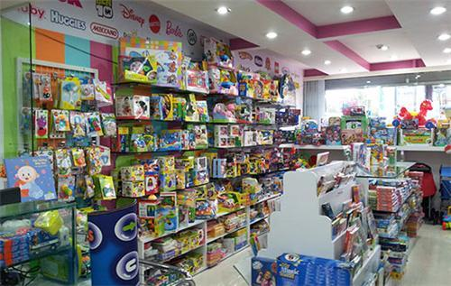
At a toy shop: Put the missing words in the gaps:
course/ lucky/pink/party/welcome
Mary: Can I ask you something Sir?
Shop assistant: Of ------------! How can I help you my dear?
Customer: I would like to have 20 plastic plates and glasses for my ----------. Do you have them in --------?
Shop assistant: Yes! Here you are! These are the last ones, you are ----------!!
Customer: Thank you
Shop assistant: You are ---------------!

Task Achievement - Two points for each answer given (10 Marks)
Well- done: 8-10
Very Good: 5-7
Good: 4-6
Needs Improvement: 1-3

Key:
Mary: Can I ask you something Sir?
Shop assistant: Of course! How can I help you my dear?
Customer: I would like to have 20 plastic plates and glasses for my party. Do you have them in pink?
Shop assistant: Yes! Here you are! These are the last ones, you are lucky!!
Customer: Thank you
Shop assistant: You are welcome!

