Exercise 1 A2 Shopping
Name: ____________________________ Surname: ____________________________ N^{ber}: ____ Grade/Class: _____
Assessment: _____________________________  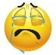  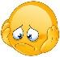 | Date: ___________________________________________________
 | Teacher’s signature:  ___________________________ | Parent’s signature:  ___________________________

Listen and write. There is one example

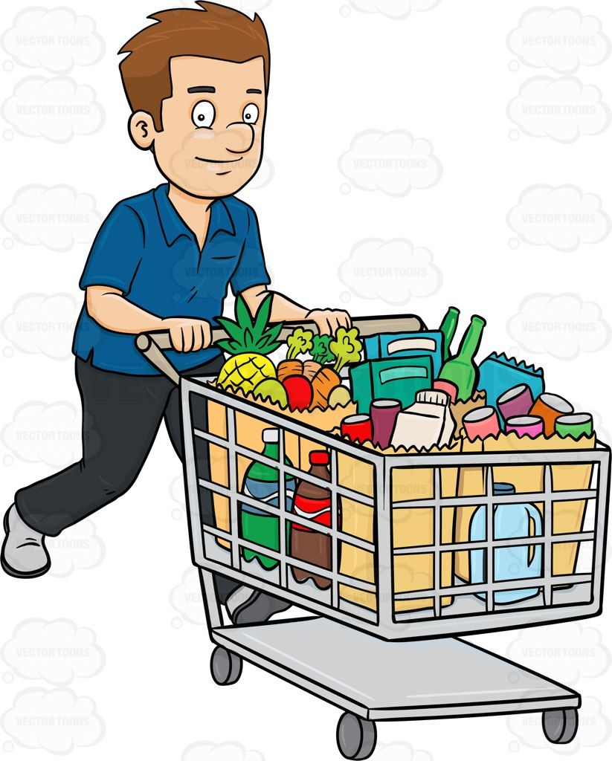

John’s shopping
e.g. He bought milk

1. He bought -----------------------
2. He didn’t buy -----------------------
3. He bought ------------------------
4. He also got ------------------------
5. But he forgot to buy -------------------------

Key: 1. Sugar 2. Oranges 3. Fruit 4. Tea 5. Bread

Transcript:
John went to the supermarket yesterday. He bought lots of things.
He bought a carton of milk, sugar and fruit but he didn’t buy any oranges as there were none left. Also, he got some tea.
When he left the supermarket, he realized that he had forgotten to buy bread…

