Ex. 4 A2 Shopping
Name: ____________________________ Surname: ____________________________ N^{ber}: ____ Grade/Class: _____
Assessment: _____________________________ | Date: ___________________________________________________
 | Teacher’s signature:  ___________________________ | Parent’s signature:  ___________________________

What shops are there in this shopping mall? Write YES or NO next to the sentences below.

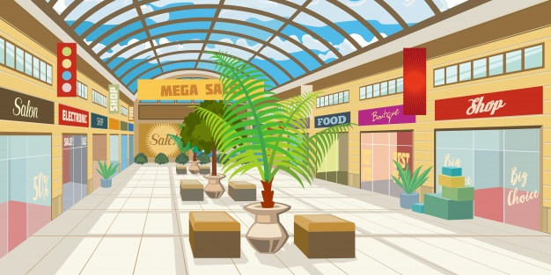

- Supermarket --------

- Sports shop --------

- Pharmacy --------

- Bakery --------

5. Café --------

Key: 1. Yes 2. Yes 3.no 4. No 5.yes

Transcript:
I love going to our local mall! There are so many shops in it and you can buy whatever you need.
There are a lot of shops selling clothes and sportswear. There is a huge supermarket where you can find anything you want.
There is a lovely café on the first floor where I meet my friends.
Unfortunately, there is no bakery so I have to get bread from the one next to my house.
Also, you cannot find a pharmacy in our mall.

