Ex 5 A2 Shopping
Name: ____________________________ Surname: ____________________________ N^{ber}: ____ Grade/Class: _____
Assessment: _____________________________  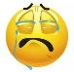 | Date: ___________________________________________________
 | Teacher’s signature:  ___________________________ | Parent’s signature:  ___________________________

Listen and write how many shops there are in the central market:

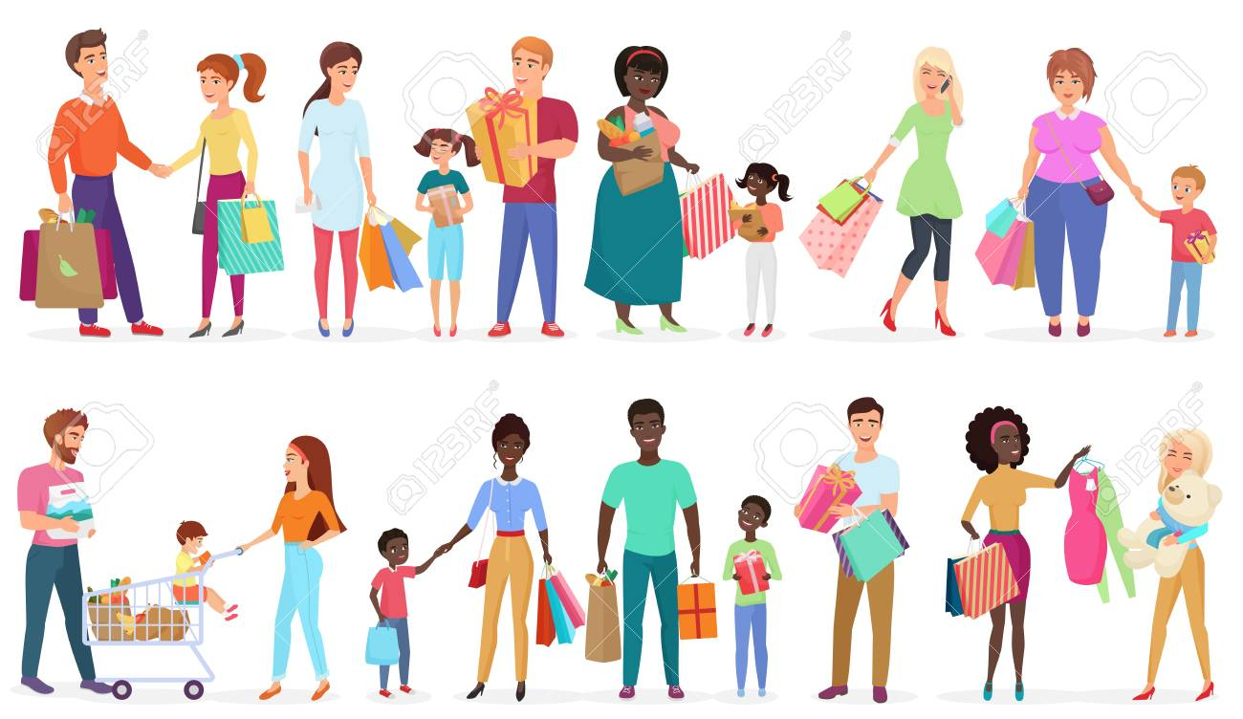
In my town, there is/are:
- 4-------------------------------------------

- 10------------------------------------------

- 3--------------------------------------------

- 2--------------------------------------------

- 1-------------------------------------------

- 2-------------------------------------------

Transcript:

My town has a very big market in the center. You can find lots of different shops there and you can have fun too.
There are 4 big supermarkets where you can find anything you want, 10 clothes shops selling nice, modern clothes and 3 bookstores with lots of books.
Also, there are 2 toy shops, 1 hairdresser and 2 dairy shops selling fresh milk and butter.

