Exercise 1 A2 shopping
Name: ____________________________ Surname: ____________________________ N^{ber}: ____ Grade/Class: _____
Assessment: _____________________________ | Date: ___________________________________________________
 | Teacher’s signature:  ___________________________ | Parent’s signature:  ___________________________

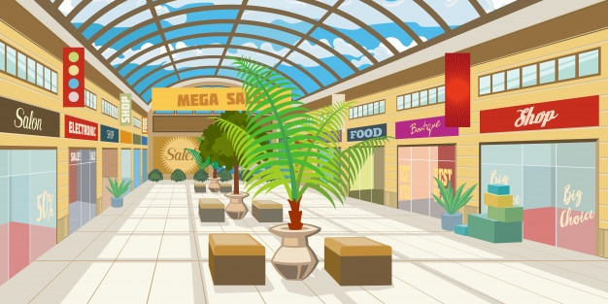

Read the text and answer the questions -

Exeter’s new shopping Mall is opening this September. It will be the biggest mall in the area It’s very close to the motorway, has its own bus station and 2000 car parking spaces, so it easy for everyone to visit it.
The mall has five areas, all under cover. The largest, Main Street, is a shopping area on three floors. Here, you’ll find all the major chain stores and department stores. You can buy fashion items and all the famous brand names.
Answer the questions:
- When is the new mall opening? __________________
- How many parking spaces are there? __________________
- How many floors are there? __________________

