Ex. 3 A2 Shopping
Name: ____________________________ Surname: ____________________________ N^{ber}: ____ Grade/Class: _____
Assessment: _____________________________  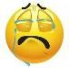  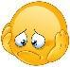 | Date: ___________________________________________________
 | Teacher’s signature:  ___________________________ | Parent’s signature:  ___________________________

Read the text and answer the questions
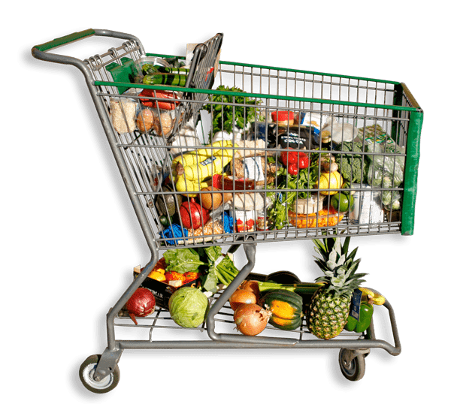
John went to the supermarket yesterday. He bought lots of things.
He bought a carton of milk, sugar and fruit but he didn’t buy any oranges as there were none left. Also, he got some tea and chocolate.
When he left the supermarket, he realized that he had forgotten to buy bread and lemons.
e.g. He bought milk
1. He bought ---------------------------------------------
2. He didn’t buy --------------------------------------------
3. He bought ----------------------------------------------
4. He also got -----------------------------------------------
5. But he forgot to buy ------------------------------------------------

