Ex. 4 A2 Shopping
Name: ____________________________ Surname: ____________________________ N^{ber}: ____ Grade/Class: _____
Assessment: _____________________________ | Date: ___________________________________________________
 | Teacher’s signature:  ___________________________ | Parent’s signature:  ___________________________

Read and fill in Nick’s shopping list
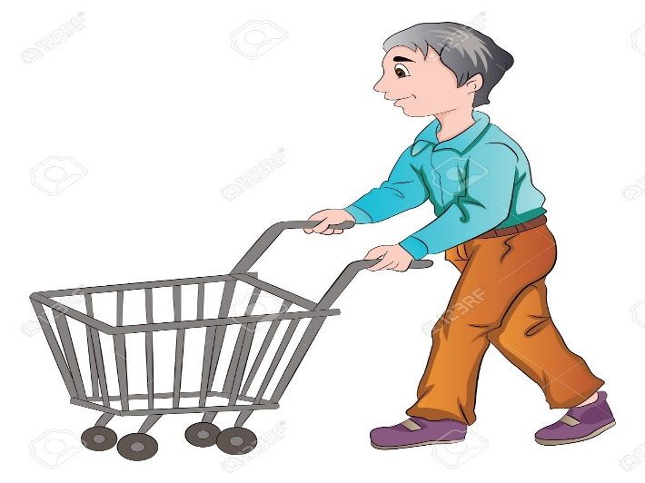
Nick is at the supermarket now and he wants to buy many things. He has made a big shopping list.
First of all, he will buy 6 eggs. He also needs bread and 2 cakes. He will buy 5 oranges and 6 lemons.
He must remember to buy 4 bananas and 3 apples. Another thing he wants to get is sugar. Finally, he will buy 7 potatoes.
There are so many things Nick wants to get that he must not forget anything!!

Nick’s Shopping List: e.g. 6 eggs

1----------------------------------------- 2. -----------------------------------------
3. ----------------------------------------- 4. -------------------------------------------
5. ------------------------------------------- 6. -------------------------------------------

7. -------------------------------------------

