Ex.5 A2 Shopping
Name: ____________________________ Surname: ____________________________ N^{ber}: ____ Grade/Class: _____
Assessment: _____________________________ | Date: ___________________________________________________
 | Teacher’s signature:  ___________________________ | Parent’s signature:  ___________________________

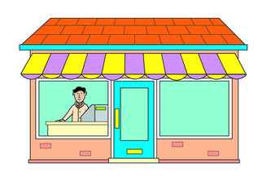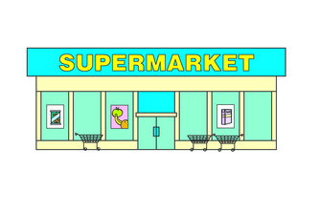

Read the text and fill in the missing words.

My town has a very big market in the center. You can find lots of different shops there and you can have fun too.
There are 4 big supermarkets where you can find anything you want, 10 clothes shops selling nice, modern clothes and 3 bookstores with lots of books.
Also, there are 2 toy shops, 1 hairdresser and 2 dairy shops selling fresh milk and butter.

In my town, there is/are:
4------------------------------------------- 10------------------------------------------
3-------------------------------------------- 2--------------------------------------------
1------------------------------------------- 2-------------------------------------------

