A2 Shopping
Name: ____________________________ Surname: ____________________________ N^{ber}: ____ Grade/Class: _____
Assessment: _____________________________ | Date: ___________________________________________________
 | Teacher’s signature:  ___________________________ | Parent’s signature:  ___________________________

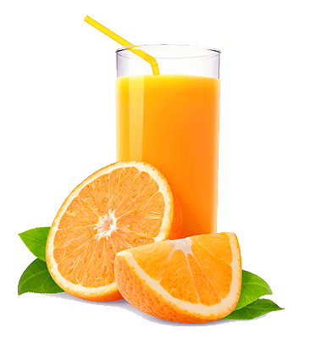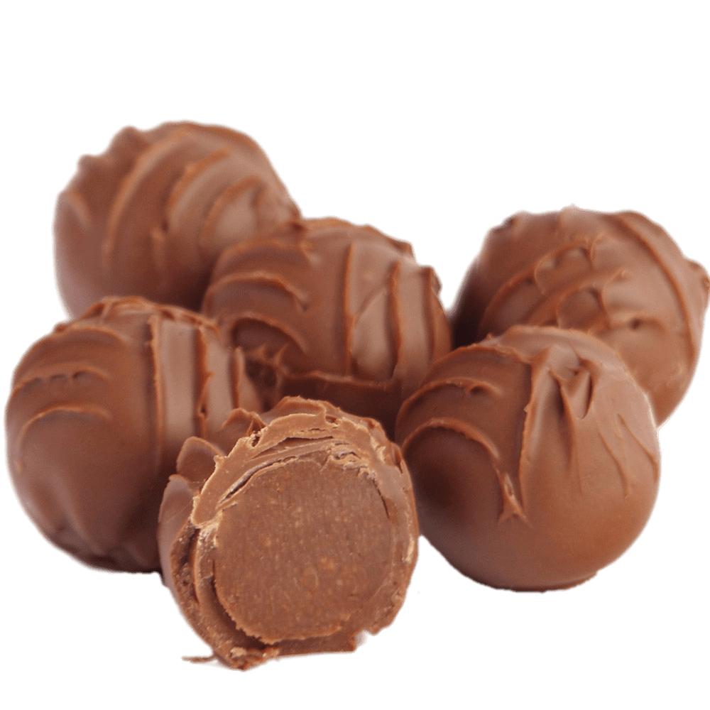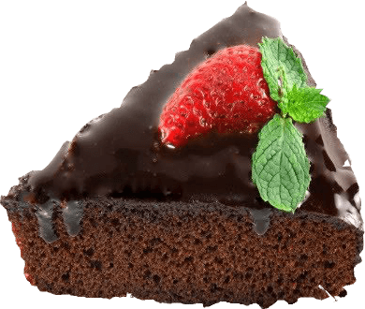

Look at the pictures and tell me which one is different from the others and why?
Where can you find these things?
Which is your favorite sweet and why?
Which is healthier than the others?

