A2 Shopping
Name: ____________________________ Surname: ____________________________ N^{ber}: ____ Grade/Class: _____
Assessment: _____________________________ | Date: ___________________________________________________
 | Teacher’s signature:  ___________________________ | Parent’s signature:  ___________________________

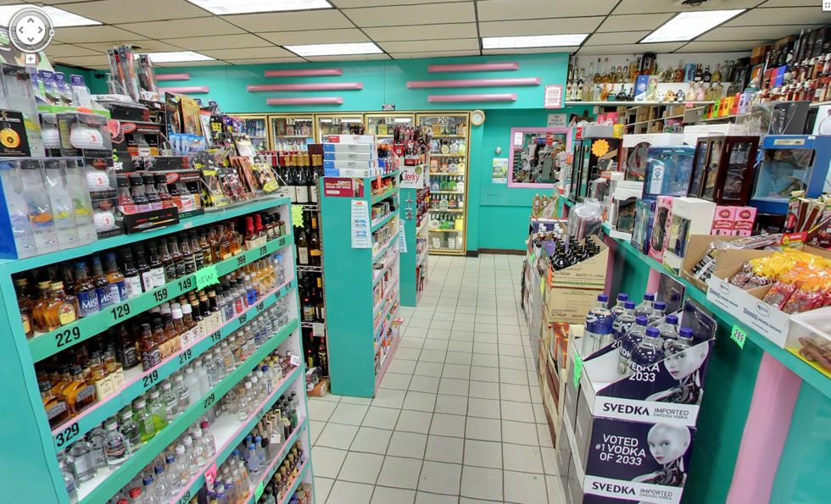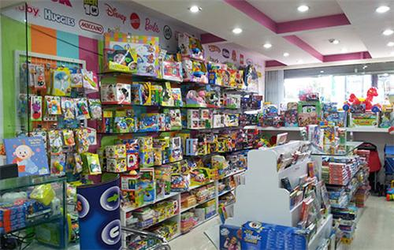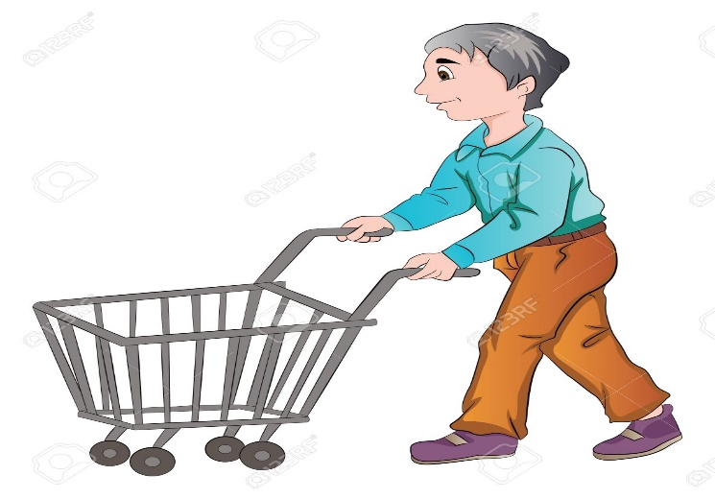

Chris wants to buy many things today. Can you help him and tell him where can he find them ?
For example: He wants to buy flowers for his wife. At a florist’s
Toys for his children? Eggs, tomatoes, cheese? Bread and cakes?
New shoes? New football boots and running shoes?

